**Project Report**

|  |  |
| --- | --- |
| Project Title | Design and Develop a website portal using Liferay |
| Qualification Name (NICF) | Advanced Certificate in Web Development using Platforms |
| Product Name | Triple-A (AAA) Company |
| Module Name (NICF) | Web Development using Platforms |

|  |  |  |  |
| --- | --- | --- | --- |
| Student name | | Assessor name | |
| Agung Yuda Pratama | |  | |
| Date issued | Completion date | | Submitted on |
|  |  | |  |
|  | |  | |
| Project Title | Design and Develop a website portal using Liferay | | |

|  |
| --- |
| Learner declaration |
| I certify that the work submitted for this assignment is my own and research sources are fully acknowledged.  Student signature: Date: |

**Content**

1. Project Background
2. Project Objectives
3. Task 1
4. Task 2
5. Task 3
6. Task 4

**Project Scenario:**

Triple-A (AAA) company is the best web host solutions service company located in downtown of Indonesia. It provides all types of services which include domain name registration, Shared Hosting, Reseller Hosting, Cloud Hosting, VPS Hosting, Dedicated Hosting, and Colocation service, etc.

**Project Objective:**

The objectives of this project are:

• To create the AAA Services company site using Liferay features for site creation and content creation

• To assign 2 users, Administrator and site member to AAA Services company site and the permissions

• To develop the customer's data management application or portlet with OOP concepts using Liferay Framework

• To prepare a class diagram for the application structure using a UML tool like draw.io, lucidchart or creately.

• To identify and investigate the design pattern used in the customer's data management application or portlet

**Tools and Platform Used :**

|  |  |
| --- | --- |
| Tool | Purpose |
| Liferay Portal Workspace 7.4.3.34-ga33 | To create the AAA Services company site and developing AAACustomerPortlet |
| Draw.io | To draw UML class diagram |
| Microsoft Word | To Write the doccumentations for web Development using platforms object |
| MySQL Workbench | To store Customer data application portlet |

**Liferay Portal Workspace 7.4.3.34-ga33**

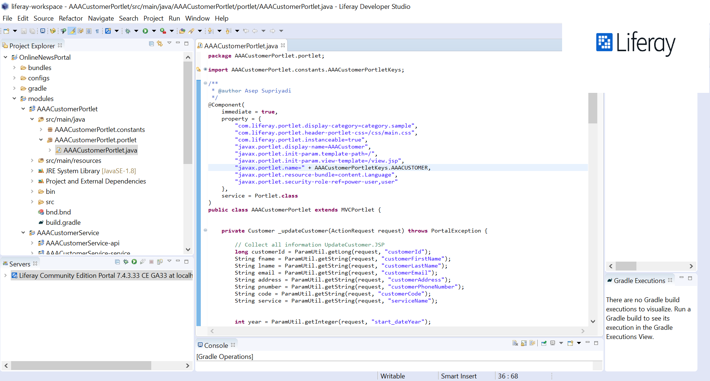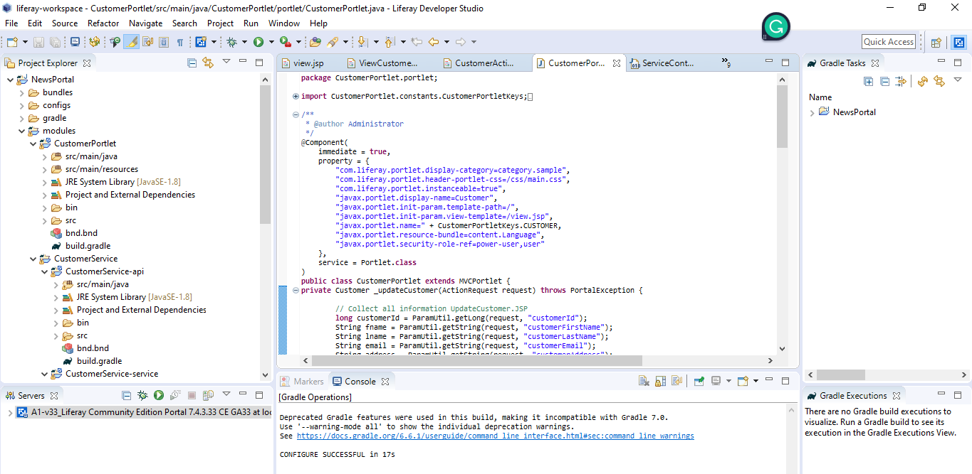

**Draw.io**

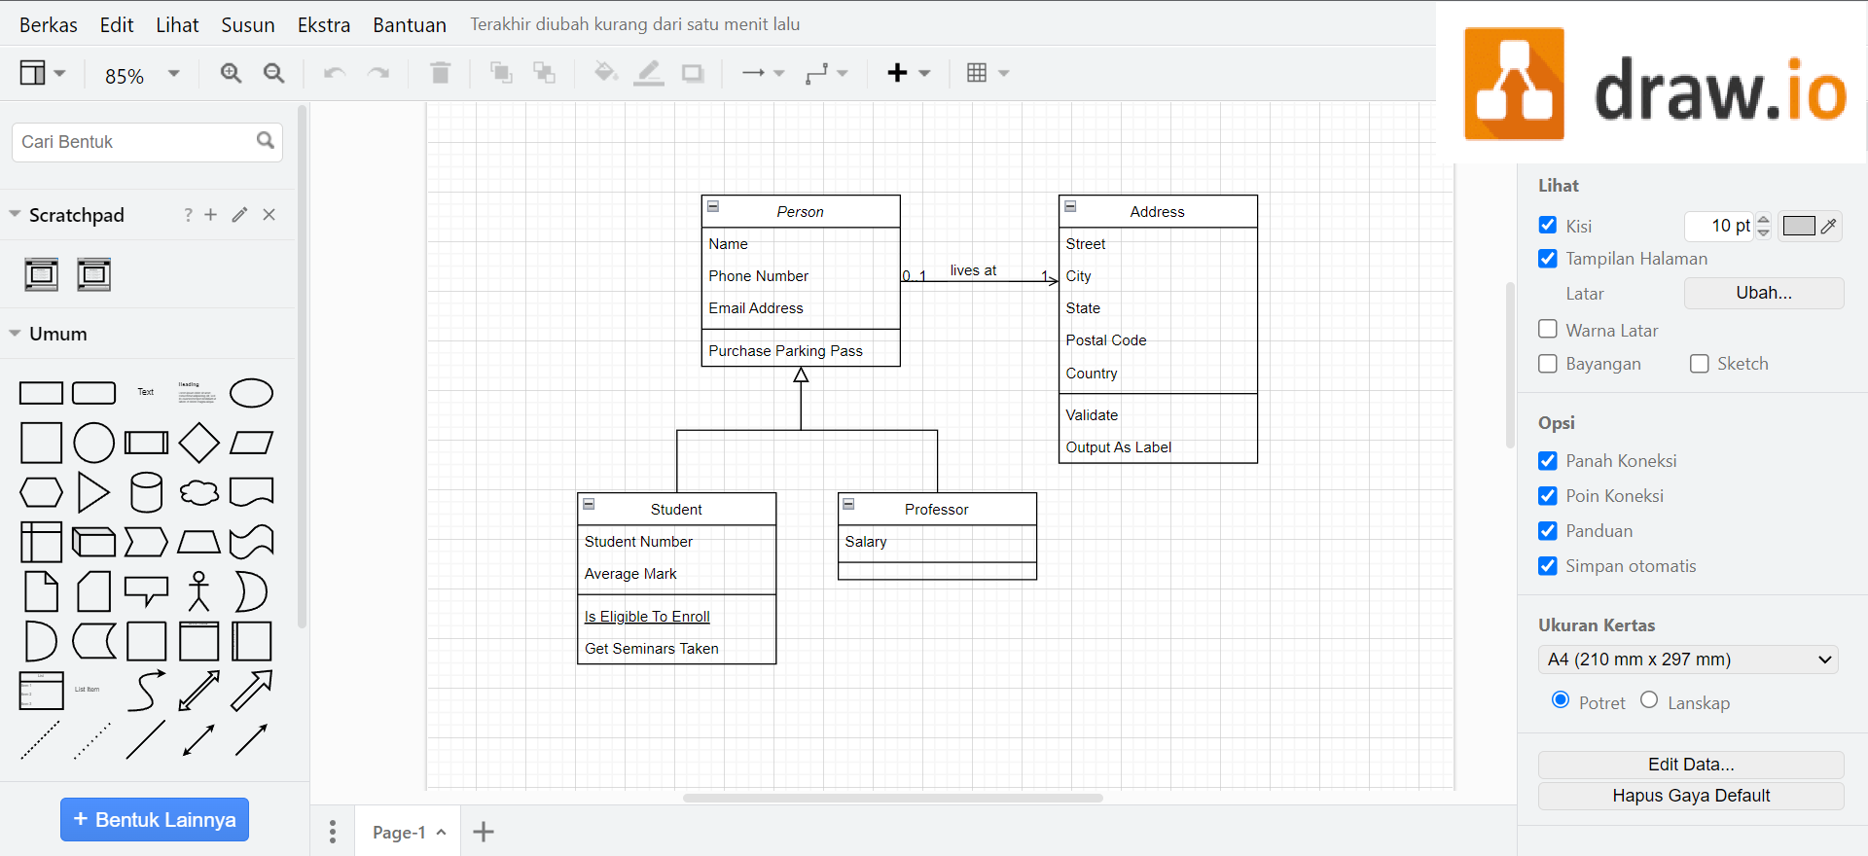

**Microsoft Word**

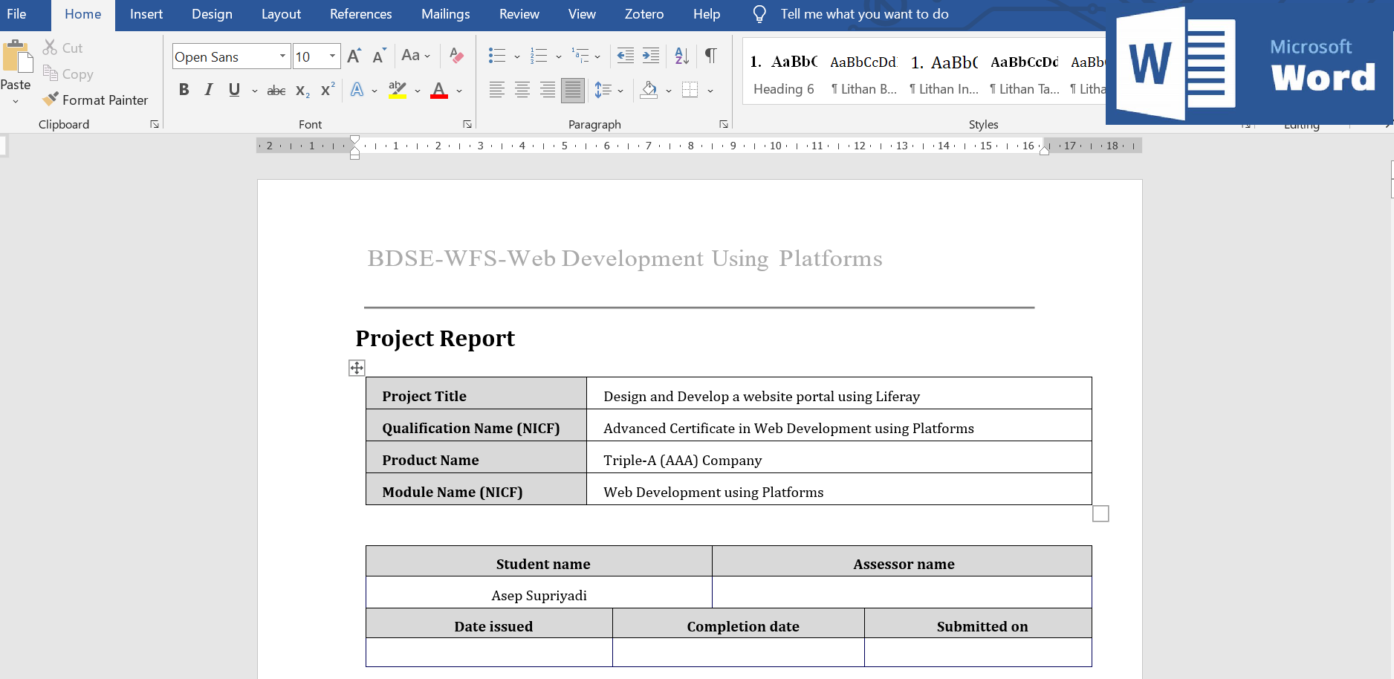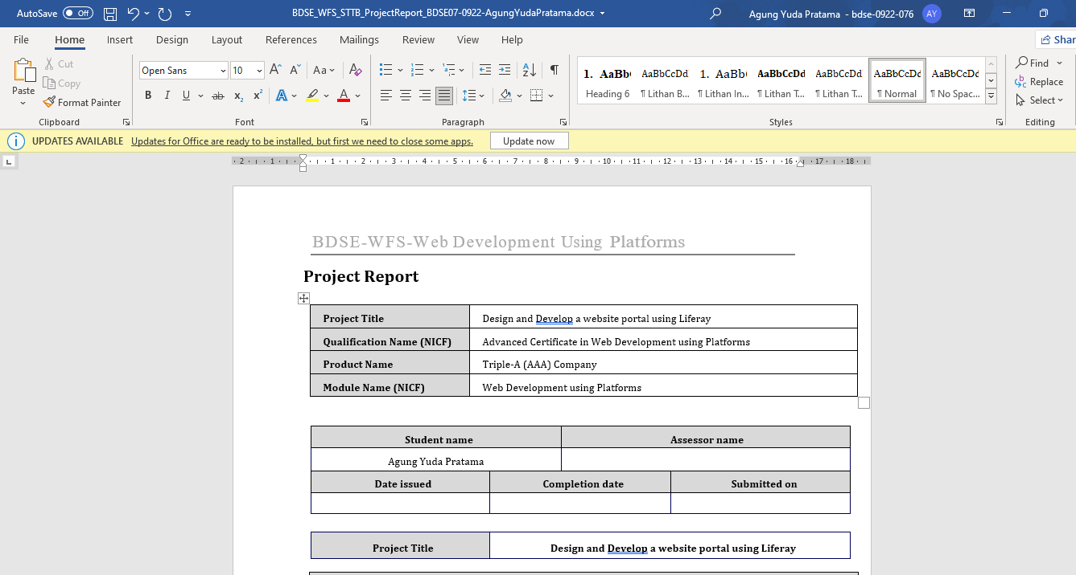

**MySQL Workbench**

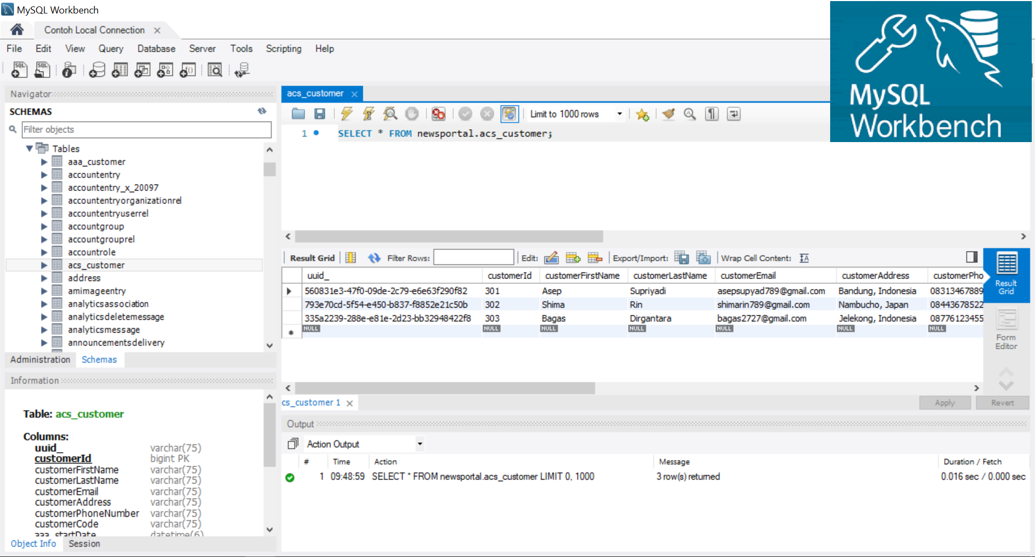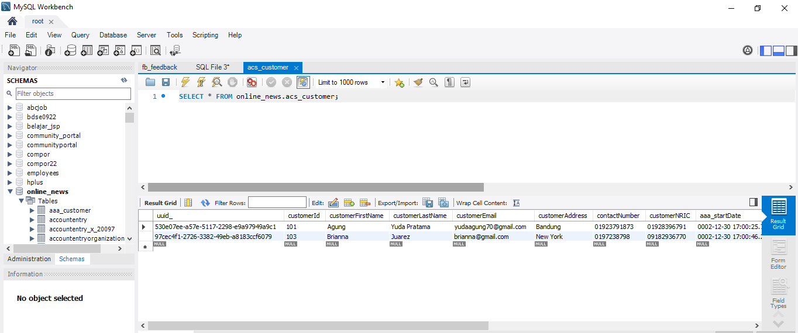

**Functional Requirements**

The AAA website consists of the following Key pages

1. Home Page

2. Registration Page

3. Login Page / Sign In

4. Our services Page

a. Domain name service page

b. Shared Hosting service page

c. Reseller Hosting service page

d. Cloud Hosting service page

e. VPS Hosting service page

f. Dedicated Hosting service page

g. Colocation service page

5. Contact us Page

6. About us Page

7. Terms and Conditions Page

Customers can purchase their services from AAA’s branch offices and needs to provide personal information such as name, email, address, national identity card number and contact number. Customers' data is a very important factor for AAA Company. To maintain and manage all of their customer information, AAA has been decided to develop an application with an object-oriented approach.

An application is required to keep track of their customer’sinfo and services given to customers. The well-organized customer data can help the company to select the correct recipients for promotions and new services.

The Scope of the Project is to build a Liferay Framework website with customer’s data management application.

The overview of the project is as below There are two types of users in this portal.

They are 1. Administrator 2. Site Member (Staff)

Administrator should be able to perform following functions in the portal,

1. Manage all of the site contents and pages.

2. Update the theme and layout.

3. Manage the customer data portlet and control permission.

4. Manage all user (Site Member and Customer) roles and permission

Site Member should be able to perform following functions in the portal,

1. Update AAA company site contents.

2. Add and Update the AAA’s customer data.

**Task 1**

**Program Paradigm and Design Pattern**

**1.** Identify and explain the characteristics of the object-orientated paradigm and relationship between the various classes from a given code scenario

1. **Explain briefly Object-Oriented Programming Paradigm.**

Object-oriented programming (OOP) is a programming style characterized by identifying classes of objects closely linked to the methods (functions) with which they are associated. It also includes ideas of inheritance of attributes and methods. It is a technique based on a mathematical discipline called "abstract data types" for storing data with the procedures needed to process that data. OOP offers the potential to evolve programming to a higher level of abstraction.

**(b) Examine characteristics of Object-Oriented Programming Paradigm**

1. Encapsulation

Encapsulation is the wrapping of data or hiding personal data from an object so that it cannot be accessed from other objects. Can only access using the current class, getter and setter methods.

Make Student.java and make the object. Make it private

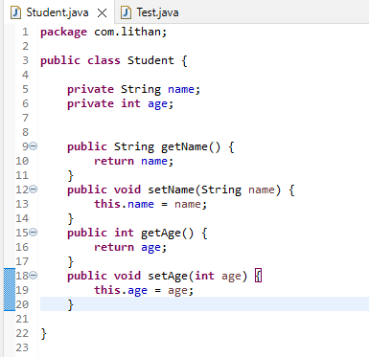

Make Test.java to test the encapsulation works or not

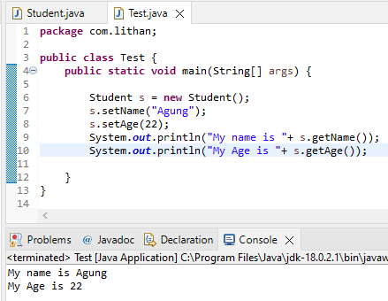

1. Polymorphism

Polymorphism (polymorphism) consists of two syllables, poly means many and morphism comes from the word morph means form. So that polymorphism in OOP programming is a term that explains that a class can have more than one method name that is the same with different contents or method bodies.

Make one method that same in several class. This is PolymorphismExample.java with the result  
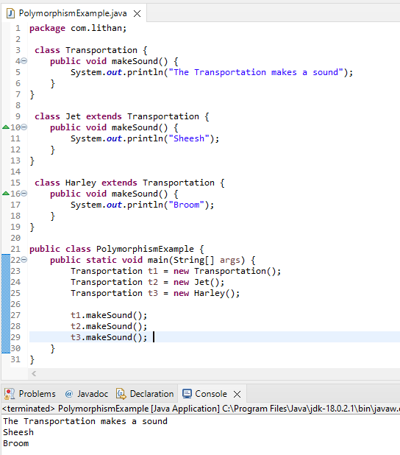

1. Constructors/ Destructors

Constructor is a special method that is used for initialization when creating an object. The constructor is called as soon as the new object is created. The feature of the constructor is that the method name exactly matches the class name.

Remember when you creating constructor the name must same with the class. This is ConstructorExample.java with result

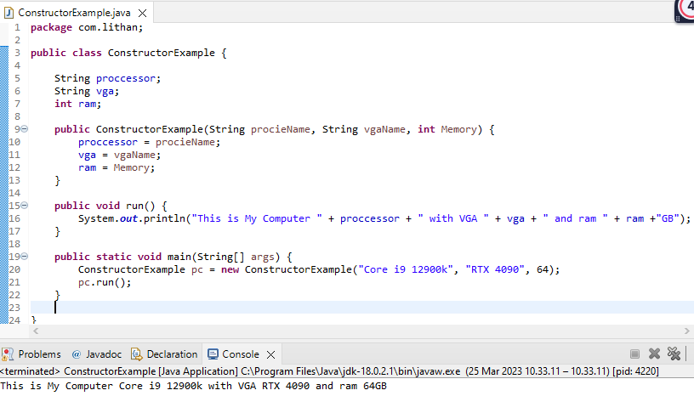

1. Abstract

Abstract is a declaration without providing details on what is declared. Abstract can be implemented in classes or methods using the abstract

keyword. The opposite of abstract is concrete (concrete) where classes and methods are declared along with their details clearly.

This is AbstractExample.java

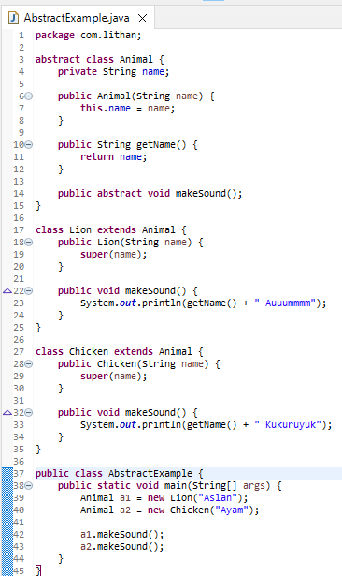

This is the result

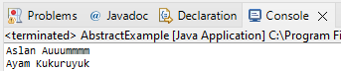

1. Interface

The interface is a class-like form in which it consists of a collection of empty methods and constants. Interfaces cannot be made objects but can only be implemented. If the class declares an object, then the interface generally expresses capabilities such as Readable, Runnable, Comparable, etc.

This is InterfaceExample.java

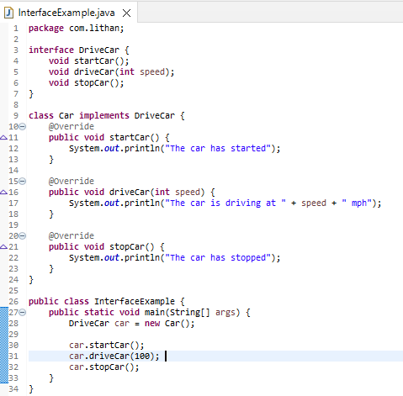

And this is the result

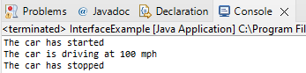

1. What are the differences between abstract classes and interfaces?

|  |  |
| --- | --- |
| Abstract | Interface |
| Use ‘abstract’ keyword to define as abstract class | Use ‘interface keyword to define as interface class |
| Can contain both abstract and non-abstract methods. | It can only contain abstract methods. |
| Allow data fields and constant to be defined | No data fields |
| Can declare constants and instance variables. | Can only declare constant. Implicitly the variables declared in the interface are public, static and final. |
| Can have constructor | Cannot have constructor |
| An abstract class can only extend one other abstract class. | An interface can extend one or more other interfaces. |
| Can have access modifiers. | Does not have access modifiers and can only be defined as public |

**(c) Examine Class Relationships using UML diagrams**

i. Inheritance

The is a relationship between two classes, primarily the parent class and the child class, which inherits the parent's structure and behavior, is represented by inheritance, also known as generalization. A solid line arrow clearly illustrates the relationship (hollow arrowhead). The three inheritance types are demonstrated below:

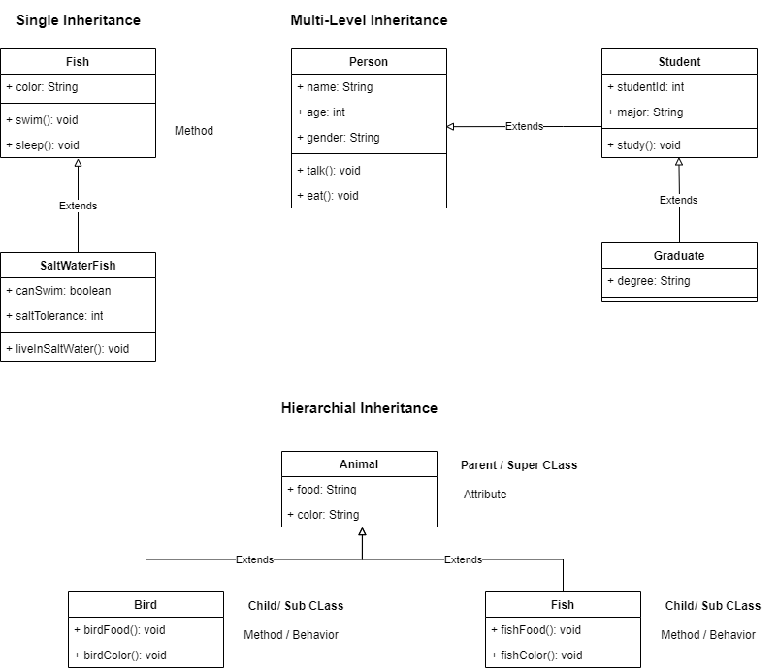

ii. Realization

Realization is seen in interfaces when the blueprint class is paired with an object to carry out each detail. A dashed line with a hollow arrowhead can be used to indicate a relationship.

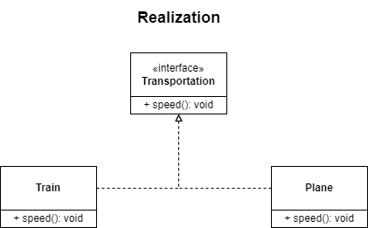

iii. Dependency

Dependency is when class A is dependent on class B. Therefore, when class B changes, class A will also be affected by the change. A dashed line with an open arrow can represent this relationship.

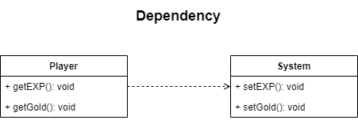

iv. Aggregation

Aggregation is the single point of control where it aggregates or assembles a group of objects that is part of the object which aggregate. The part of the relationship can be represented by a solid line with an unfilled diamond at the parent end connected to the child class. In this case, if the parent is deleted, the child class can still exist independently.

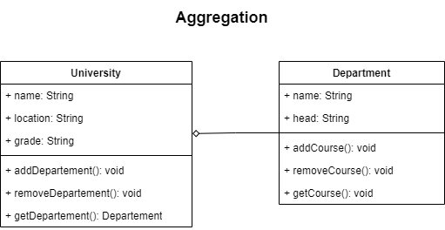

v. Composition

Composition is the stronger form of aggregation. In this case, if the source or the aggregator is destroyed, then part of it is also destroyed with it and cannot stand by itself. The relationship is displayed with a solid line and the filled diamond at the associated/source end connected to the composite class.

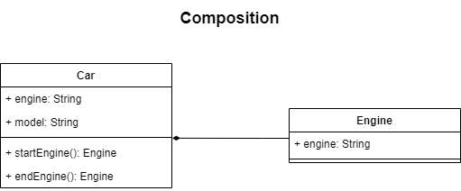

**(d) Examine and list out class relationships which are used in project scenario.**

* + - 1. **Inheritence :**

Administrators, Site Members, and customer classes have

common variables and methods, they all use inheritance from the User, a

new super class with generic variables and methods.

* + - 1. **Association :**

Administrators can only manage customers and site members, and site members can only handle customers, so the relationship between administrators and customers, administrators and site members, and site members and customers is unidirectional.

**2. Identity the suitable design patterns based on the project scenario.**

1. What is creational design pattern?

The process of making objects is the focus of creational design patterns. When a choice needs to be made during the instantiation of a class, these design patterns are employed (i.e. creating an object of a class).

* Factory Method Pattern

To create an object, simply define an interface or abstract class and leave it up to the subclasses to choose which class to instantiate.

* Abstract Factory Pattern

without mentioning their specific concrete sub-classes, define an interface or abstract class for assembling families of related (or dependent) objects. That means Abstract Factory lets a class returns a factory of classes.

* Singleton Pattern

Create a class with a single instance that has a single point of global access. In other words, a class must ensure that only single instance should be produced and all other classes can utilize single objects.

* Prototype Pattern

Cloning an existing object allows for customization and avoids the need to create a new one.

* Builder Pattern

Construct a complex object from simple objects using step-by-step approach

* Object Pool Pattern

Contains a certain number of items. When an object is taken from the pool, it is not available in the pool until it is put back. The lifespan of each object in the pool is creation, validation, and destruction.

1. Identify suitable design pattern for “AAA Portlet”

The Most suitable design pattern for AAA Portlet is **The Factory Method Patern.**

c) What is structural design pattern?

A structural design pattern is a guide for combining various objects and classes to create a larger structure that can accomplish several objectives at once. The patterns in structural designs demonstrate how distinctive system components can be put together in a flexible and extensible way.

* Adapter Pattern

By utilizing an adaptor, this pattern enables cooperation or interaction between objects with various interfaces.

* Bridge Pattern

The bridge pattern involves a bridge structure or interface which can be separated from its implementation class and used by an abstract class.

* Composite Pattern

In terms of a tree structure, the composite pattern is used to represent either a partial or complete hierarchy of objects. A class that contains a collection of its own objects can be formed.

* Decorator Pattern

Decorator pattern also known as a wrapper allows adding new functionality to an existing object without any change to its structure. The solution is by encapsulating the original object inside an abstract wrapper class and therefore unlimited number of decorators can be added to each core objects

* Facade Pattern

The facade design makes a single facade class the only point of access by wrapping or encapsulating a complicated subsystem inside of it. The consumer will only be able to use the Facade and will not be exposed to the system's hidden complexity.

* Flyweight Pattern

Reduce object count creation to improve performance from a decrease in memory footprint. This method is suitable when there is a need to create large number of similar objects through the use of stored (shared) object in the Flyweight object called the intrinsic state allowing reusability when required. The extrinsic state is the non-shareable state among objects. A key note to the flyweight patter is that the construction is not modifiable, therefore, the flyweight object is immutable.

* Proxy Pattern

The proxy pattern also knows as the placeholder or surrogate provides control for accessing the original object to protect it from the outside world. This pattern can be use in different kind of scenario like a Protective Proxy by acting as the authorization layer to form restriction on internet access at home as an example.

1. Identify suitable design pattern for “AAA Portlet”

The Most suitable design pattern for AAA Portlet is **The Facade Patern.**

e) What is behavioral design pattern?

Behavioral design patterns are concerned with the interaction and responsibility of objects. These design patterns call for the interaction of the items to be loosely connected while still allowing for easy communication between them.This means that in order to prevent hard coding and dependencies, the implementation and the client should be loosely connected.

* Chain of Responsibility Pattern

This pattern involves passing requests down a line of handlers, each of which makes the decision as to whether to process the request or pass it on to the following handler.Bridge Pattern

The bridge pattern involves a bridge structure or interface which can be separated from its implementation class and used by an abstract class.

* Command Pattern

The command is the request included within an object and is included within an object and is passed to an invoker object, which determines which object is best suited to handle the command before handing it on to the object for execution.

* Interpreter Pattern

Given a language, the interpreter constructs a representation for its grammar to translate sentences in the language. This pattern incorporates formal grammar.

* Iterator Pattern

Allow to traverse a collection of elements for example in a list without exposing the underlying structure of the object.

* Mediator Pattern

By employing the mediator class, which manages all interactions, the mediator objects reduce the complexity of communication across various classes and capture how objects interact with one another.

* Memento Pattern

This pattern enables the return of an object to its prior state without disclosing the specifics of how it was implemented. The memento object is used to preserve the initial state of the creator while still adhering to encapsulation.

* Observer Pattern

This pattern supports broadcast-type communication; when one object's state changes, the others are alerted and change automatically.

* State Pattern

Alter an object's behavior when its state changes

* Strategy Pattern

Encapsulates an algorithm inside a class

* Template Pattern

The template pattern divides an algorithm's skeleton into a number of parts and defers some steps to subclasses so they can replace the steps to implement it.

* Visitor Pattern

Defines a new operation to a class without change

* Null Object

This pattern is used to provide suitable default when there is an absence of an object.

f) Identify suitable design pattern for “AAA Portlet”

The Most suitable design pattern for AAA Portlet is **The Template Patern.**

**3. Examine how the object-orientated paradigm and its key principle is identified in each of the design patterns.**

Object-oriented programming (OOP) is a programming style characterized by identifying classes of objects closely linked to the methods (functions) with which they are associated. On the other side, design patterns are reusable fixes for typical issues in software design. The foundation of many design patterns is the object-oriented paradigm.

Each design pattern references the object-oriented paradigm and its fundamental ideas of encapsulation, inheritance, polymorphism, and composition. Encapsulation is used by the Singleton Pattern, inheritance is used by the Factory Method Pattern, the Adapter Pattern uses polymorphism, the Decorator Pattern uses composition, and abstraction and encapsulation are used by the Observer Pattern.

Overall, these design patterns demonstrate how the object-oriented paradigm is focused on using classes and objects to organize and encapsulate code, while also emphasizing principles like inheritance, composition, polymorphism, and abstraction to create flexible and extensible systems. The relationship between the object-oriented paradigm and design patterns is one of interdependence. The object-oriented paradigm provides the foundation for design patterns, while design patterns help to demonstrate the usefulness of object-oriented concepts and highlight areas where improvements can be made.

**Task 2**

**System Design**

**1. Design and build class diagrams based on project scenarios using a UML tool.**

1. **Draw Class Diagrams showing Class-relationships**

**What is Class Diagram**

A class diagram is an effective tool for describing different Design Patterns. In many instances, a class diagram is required to represent the crucial elements of a specific pattern completely. This is due to the fact that a class diagram offers a thorough depiction of a system's static structure while emphasizing key connections between classes, objects, characteristics, and activities. A class diagram can assist designers in better understanding the system’s overall architecture and pinpoint key areas for optimization and development by offering a conceptual model of the system in terms of entities and their relationships. Including classes, interfaces, relationships, collaborations, and limitations in a well-designed class diagram also contributes to its ability to withstand even the most challenging and complex real-world scenarios.

Modifiers are used to indicate visibility of attributes and operations.

1. ‘+’ is used to denote Public visibility (everyone)

2. ‘#’ is used to denote Protected visibility (friends and derived)

3. ‘-’ is used to denote Private visibility (no one)

By default, attributes are hidden and operations are visible.

**Base on the scenario, define the classes, attributes, and methods**

|  |  |  |  |
| --- | --- | --- | --- |
| **Classes** | **Purpose** | **Attributes** | **Methods** |
| Administrator | 1. Manage all of the site contents and pages.  2. Update the theme and layout.  3. Manage the customer data portlet and control permission.  4. Manage all user (Site Member and Customer) roles and permission | Inherit from Users | manageSites()  managePermissions()  manageUsers()  manageCustomer() |
| Site Member (Staff) | 1. Update AAA company site contents.  2. Add and Update the AAA’s customer data. | Inherit from Users | addCustomer()  updateCustomer() |
| Users | Describes the two user categories in the AAA Aspire Hosting | aaa_userId  aaa_userName  email  password | manageContents(), register(), login(), logout() |
| Customer | Buy the service | customerId, customerFirstName, customerLastName, customerEmail, customerAddress, contactNumber,  customerNRIC, aaa_startDate  serviceName | buyService() |

**Class Diagram**

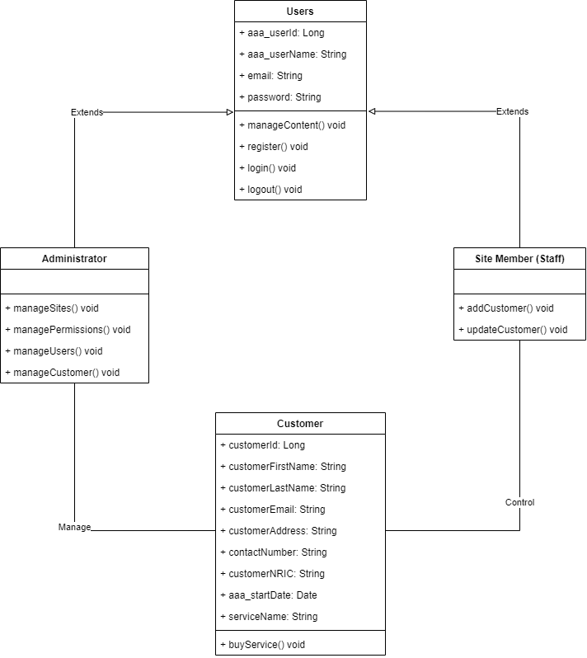

**(b) Explain relationships between classes**

Administrator and site member, two subclasses of the superclass Users, are shown to have an inheritance relationship by a solid line with a hollow arrowhead. This is so because AAA Aspire Hosting has two different kinds of users—the Administrator and the site member. Due to their shared properties of name, email, and similarity in managing contents, registering, logging in, and logging out via the Generalization relationship, both of the two classes are the sub class of the super class Users.

As the administrator is in charge of managing the customers, there is also a relationship between Administrator and Customer that is represented by a single solid line. Site users interact with customers since they are in charge of managing them.

**2. Identify possible situations where design patterns would be beneficial and then develop the UML diagrams reflecting the design patterns.**

**The factory method** is beneficial in acting as the knowledge centre for producing required objects. The getInstance() method in the serviceContext Factory class is reusable depending on the needed serviceContext object for Customer used to get respective user id to update the customer. The user which uses the Customer Portlet will refer to the factory when they need to create the serviceContext object without knowing the complicated creation logic.

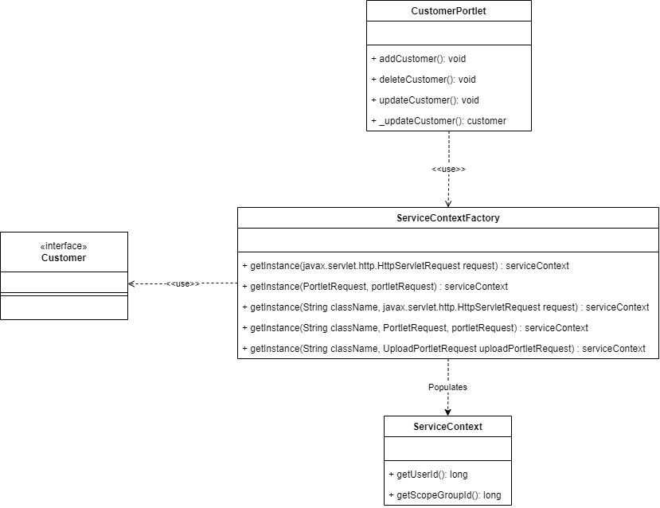

**The facade pattern** is beneficial in terms of hiding or minimizing the sub classes complexity as the CustomerLocalServiceUtil class is the only point of access for the user to implement the company business logic using the CRUD operation. The mentioned class is regarded as a façade class that reduces overall complexity by serving as a common interface that anyone who uses the CustomerPortlet can access.

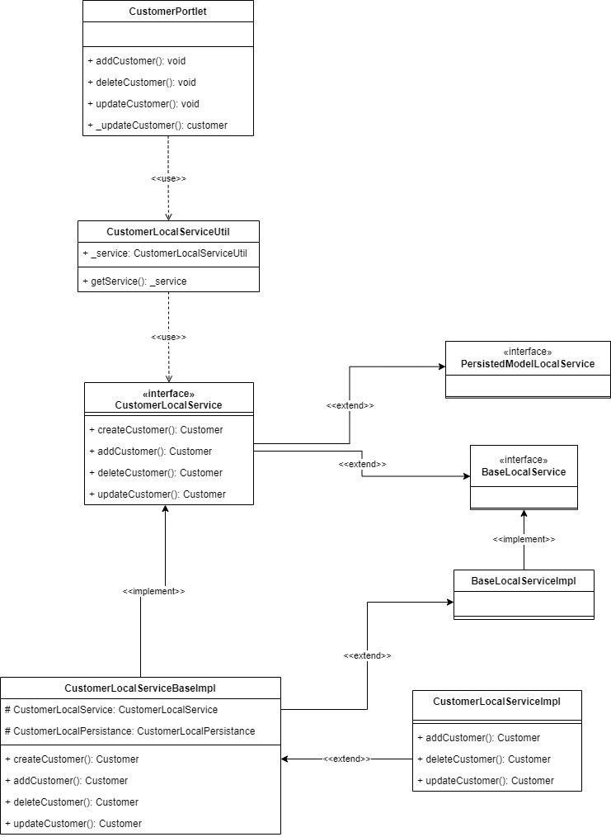

**The Template method** by reusing the code, it is possible to create numerous variations of the same object structure. Customer Portlet has a structure that is similar to that of Abstract GenericPortlet, allowing some of its methods to be implemented. This allows for the creation of various portlets, such as welcomePortlet and greeting Portlet.

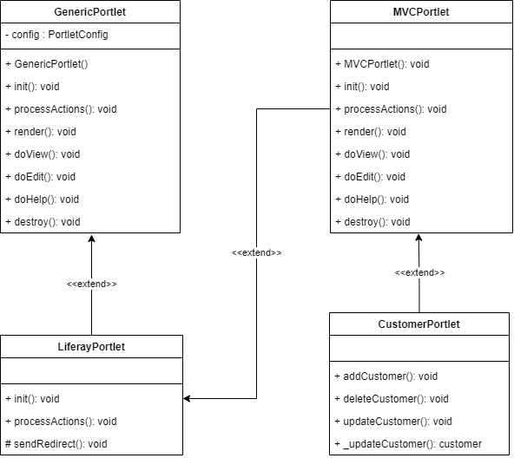

**Benefits of Design Patterns**

Many object-oriented programming (OOP) issues are addressed through design patterns. The issues may relate to the construction of an object, the structuring of an object to create a bigger structure, or the communication of an object (behavioural). The benefits are:

1. Reusability—the pattern can be used again and again in different projects

2. It is possible to create an organized system

3. System design can be made more transparent to ensure that the system architecture is clear, which will help you create better applications.

**3. Observe how the class diagrams are reflected from a given scenario by using the UML tool.**

According to the UML class diagram for the factory design pattern, the user can quickly obtain various serviceContext objects for Customers using the serviceContextFactory or the factory class. This is because the factory method getInstance() is reusable depending on the model or object the user wishes to get its associated id for, allowing for updating customer information.



The following was possible as the serviceContext aggregates necessary information like returning the current user ID method. Aggregation relationship is observed as the ServiceContextFactory.getInstance(..) methods, populates the ServiceContext with information from a request object (Liferay, n.d.)

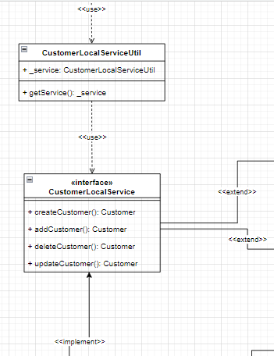

For the facade design pattern class diagram, it is observed that the CustomerLocalServiceUtil class was frequently used to achieve the operation of adding customer, deleting customer, updating customer and also the same case for the services. The class shows a dependency to the CustomerLocalService interface containing the mentioned operations required by the administrator. The Util class or the facade is able to hide the complexity beyond this class and thus simplifies the administrative methods. Generalization relationship is also identified between the interface and CustomerLocalServicelmpl class which implements the interface methods. Also, the generalization or inheritance is shown as the Impl class extends the super class BaseLocalService and PersistedModeLocalService.



The generic relationship between the abstract class GenericPortlet and its subclasses, which override the method implementation without altering the abstract class structure, is demonstrated by the template design pattern.

**Task 3**

**System Development**

**1. Set up a project, build an application based on your derived UML class diagrams and design patterns. Provide screenshots as evidence.**

1. Create MVC Portlets (Customer and Service) to manage AAA customer’s

data

Create liferay module project and set like this

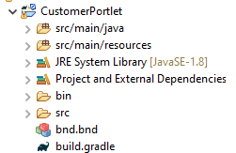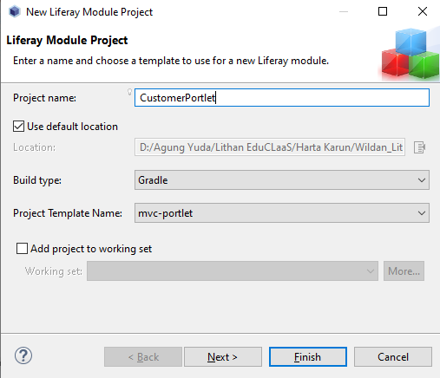

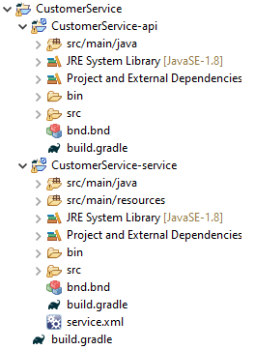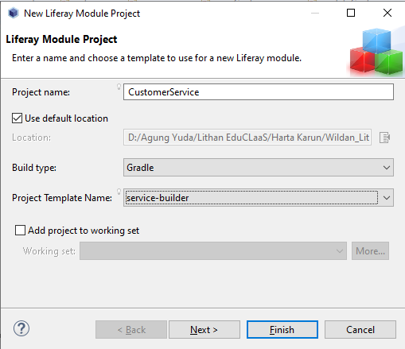

2. Build required entities using service builder.

After the service has created, you can go to the service.xml in service service portlet. Double click on that, go to overview, and create the entity

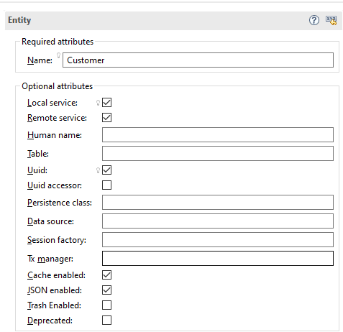

3. Provide the screen capture of service.xml

Go to source and you can see the code

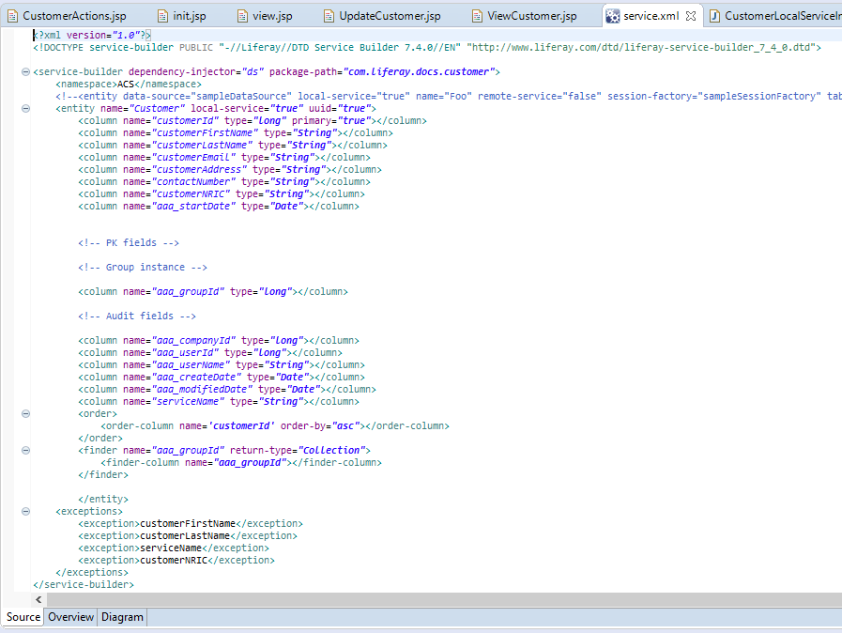

4. Provide screen capture of Service Layer

Go to CustomerService\CustomerService-api\src\main\java\com\liferay\docs\customer\service

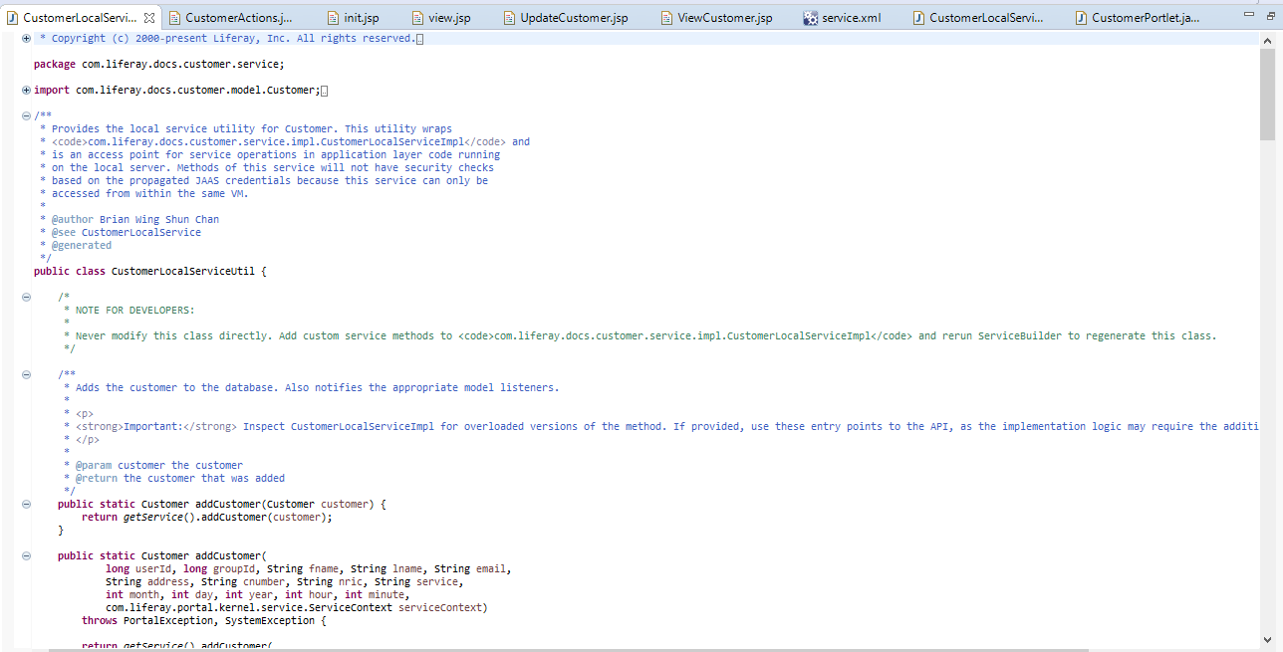

5. Provide screen capture of Controller Class

Go to CustomerPortlet\src\main\java\CustomerPortlet\portlet

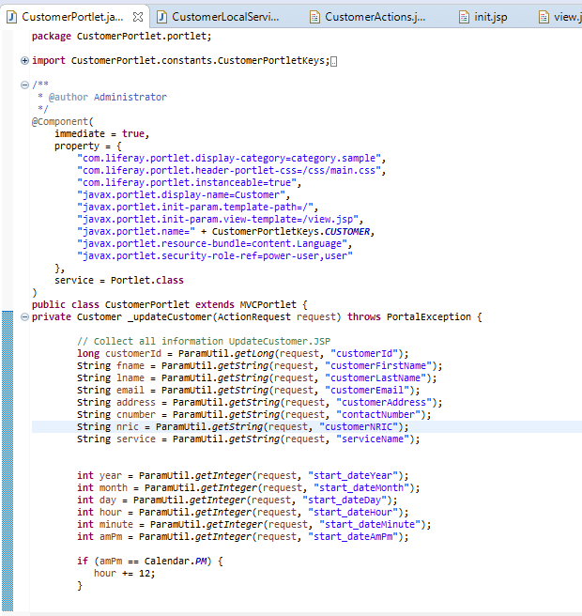

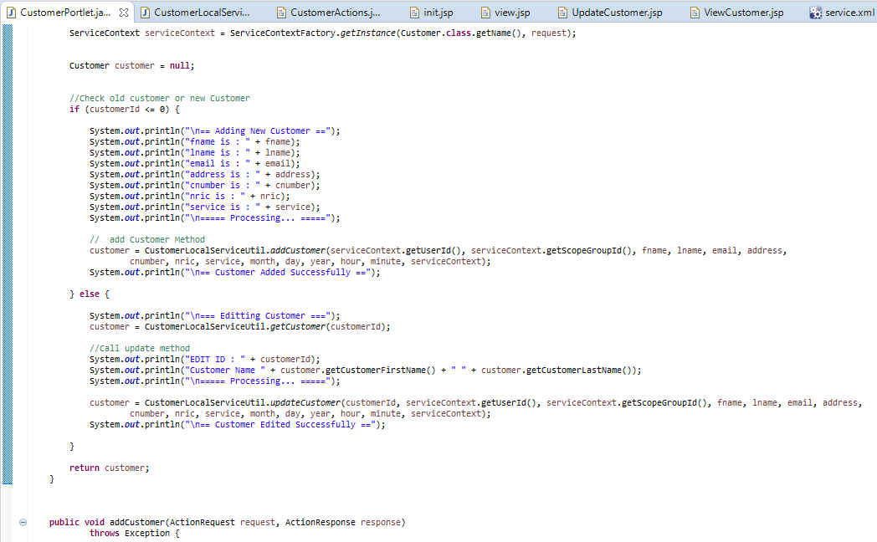

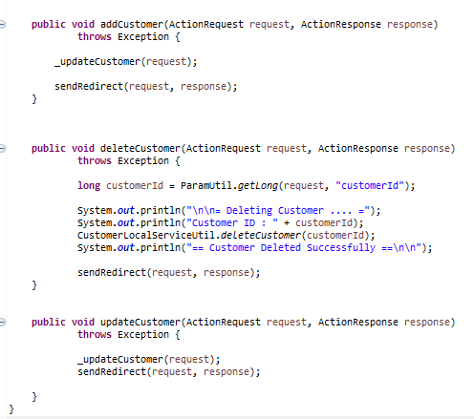

6. Provide screen capture of required jsp files for “AAA Customer and Service

Portlet”.

Go to CustomerPortlet\src\main\resources\META-INF\resources

* **Init.jsp**

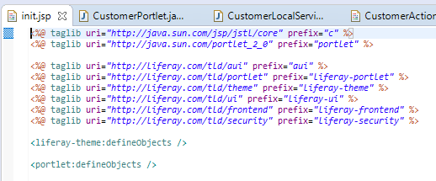

* **View.jsp**

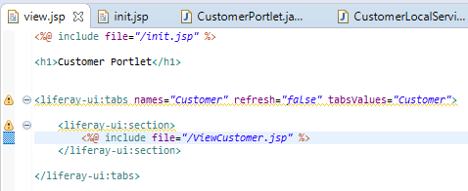

* **viewCustomer.jsp**

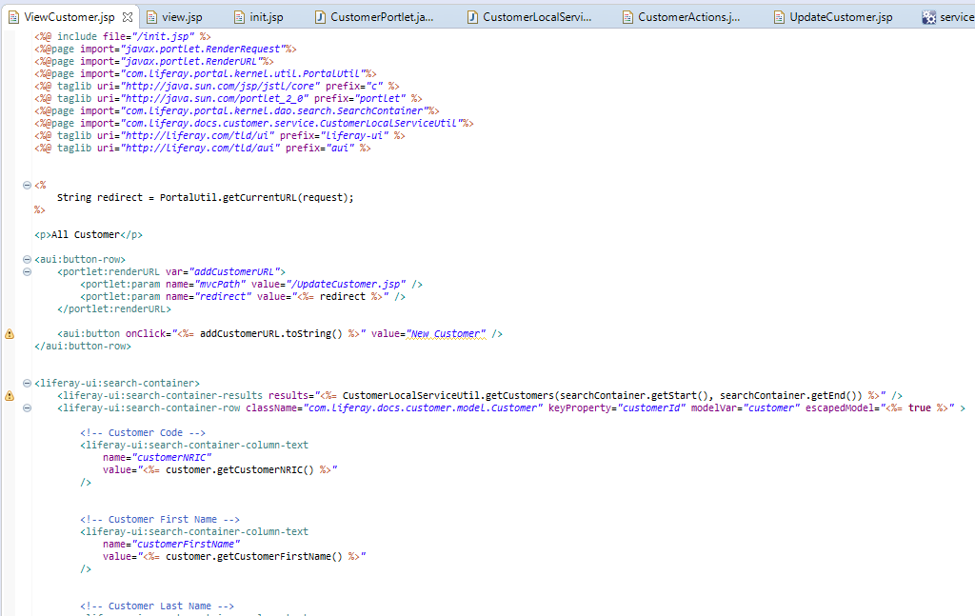

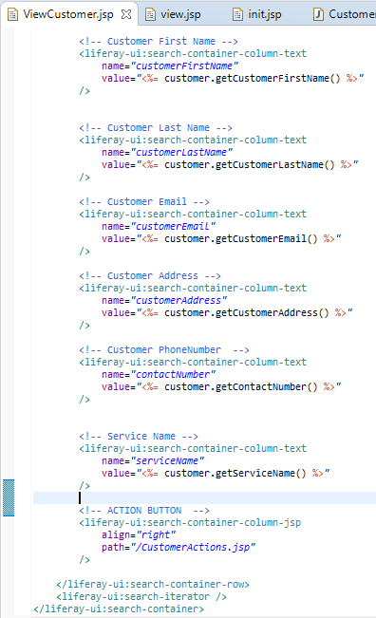

* **updateCustomer.jsp**

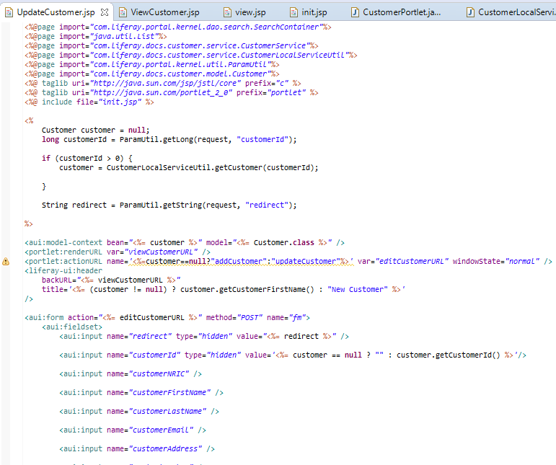

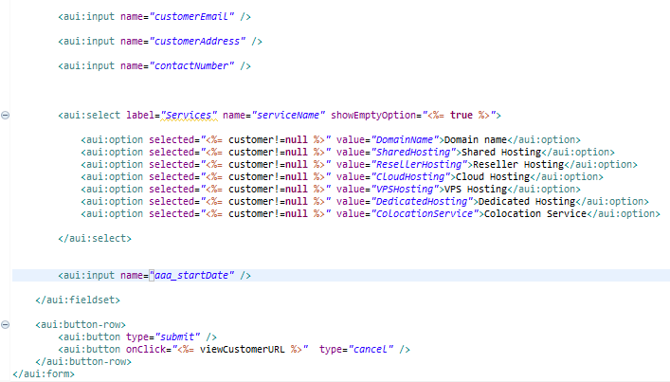

* **customerActions.jsp**

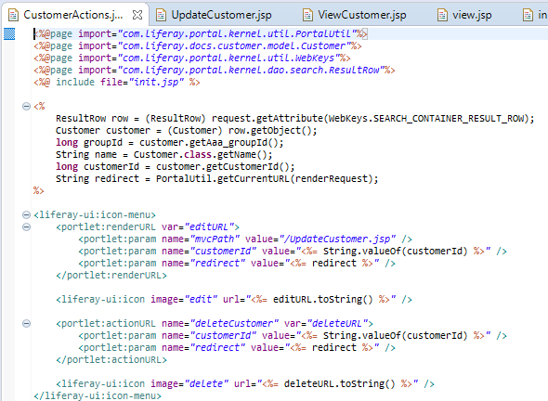

7. Create the Triple-A (AAA) company webpages. Take the screen captures of the following pages along with your Admin Account Name (Make sure that admin must be registered with Your Name)

**Admin Account Name**

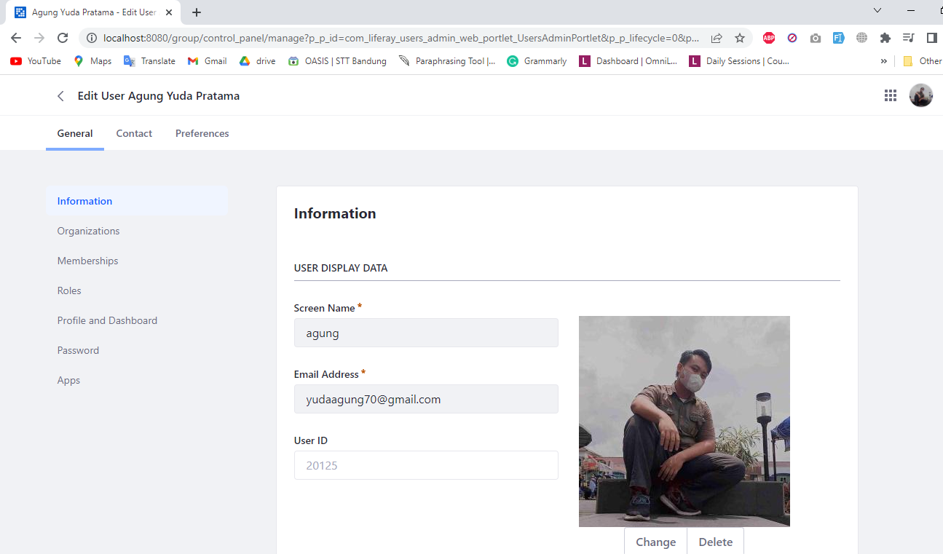

**Admin Roles**

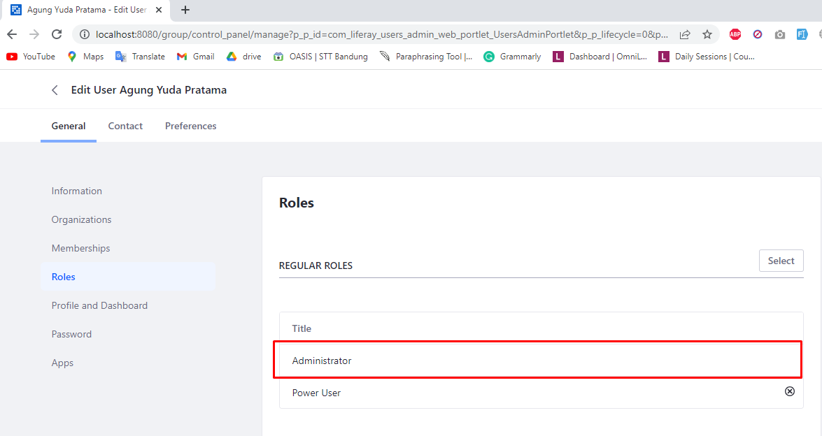

**Site Member(Staff) Account Name**

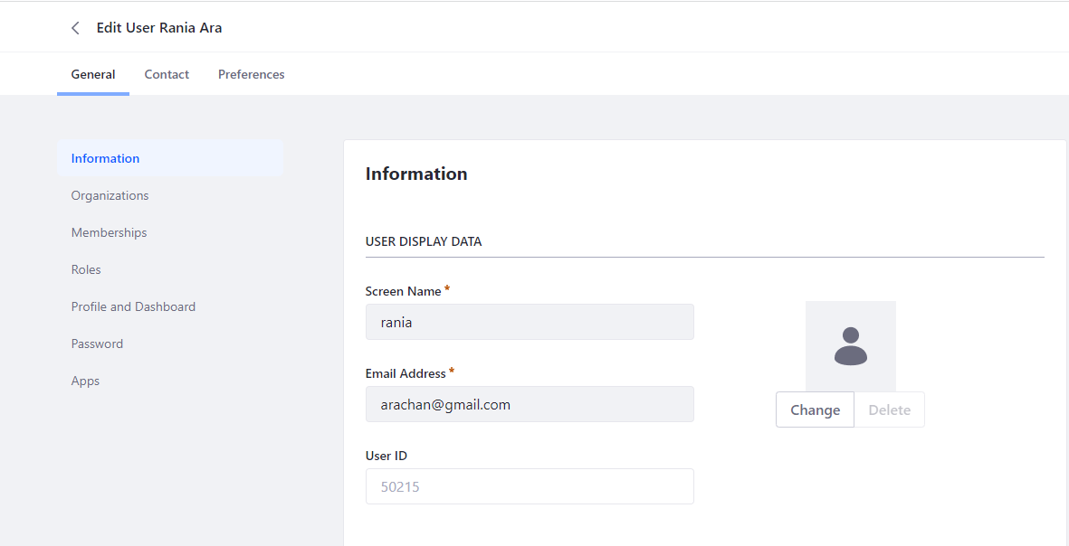

**Site Member(Staff) Roles**

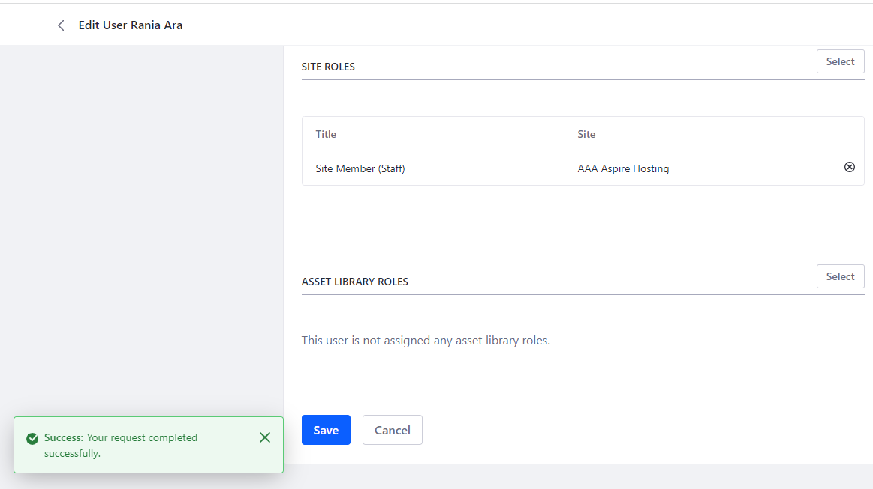

**Site Member (Staff)**

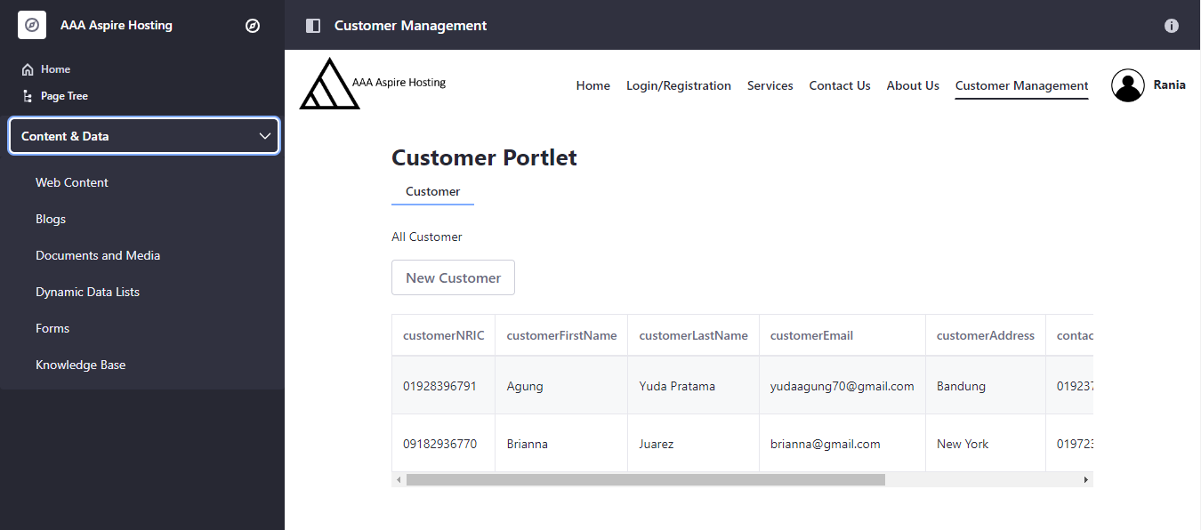

a) Home Page

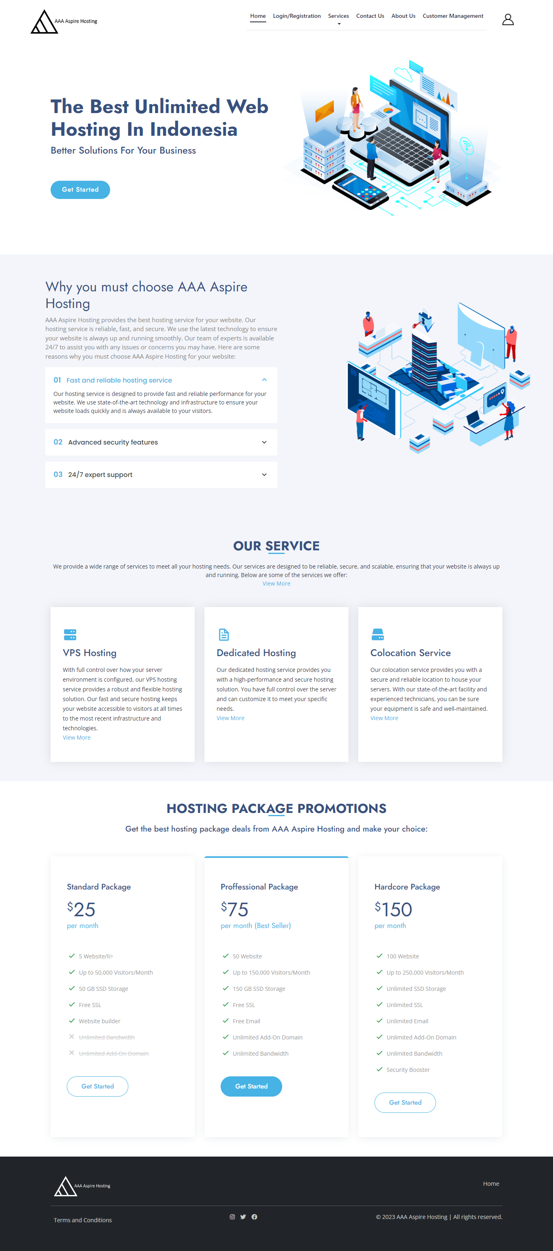

b) Our Services Page

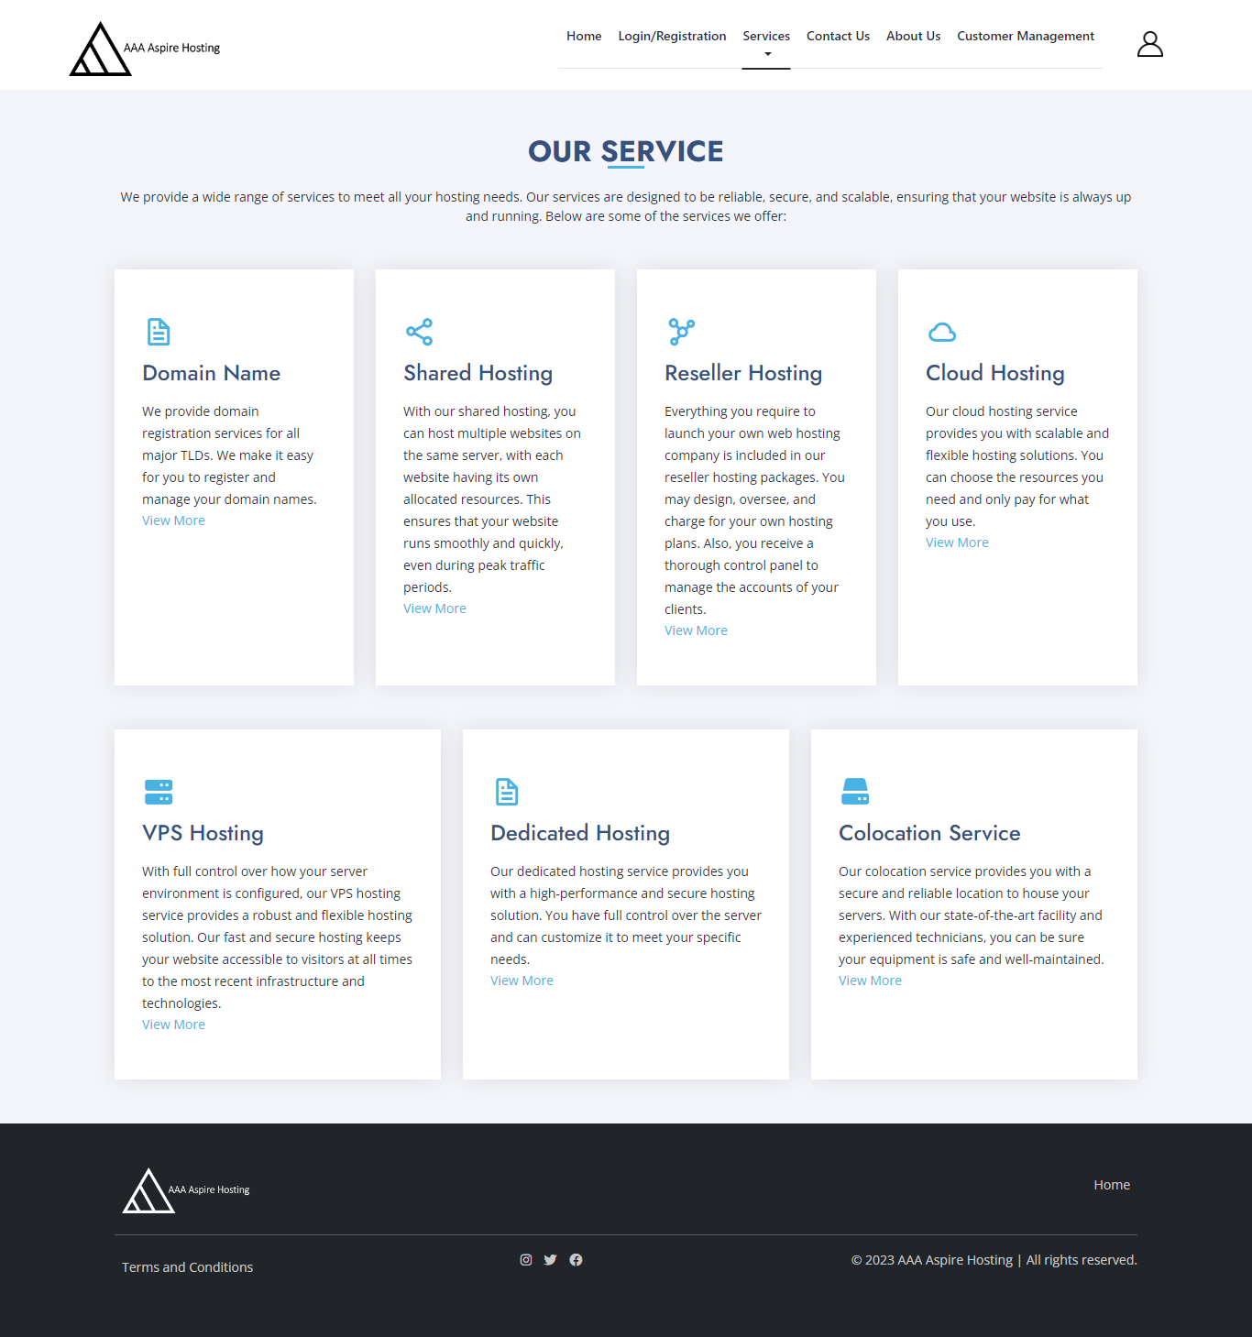

* + - 1. Domain name service page

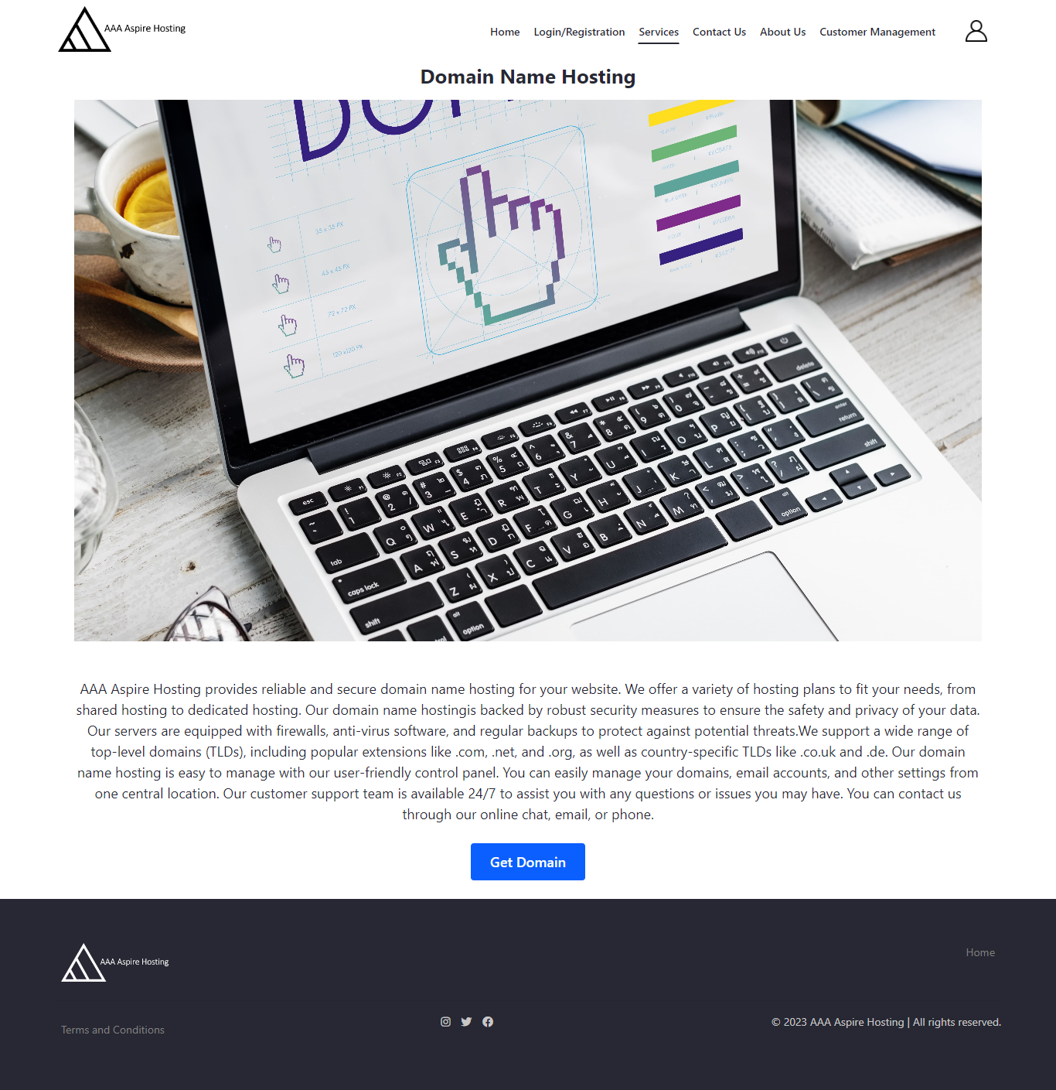

* + - 1. Shared Hosting service page

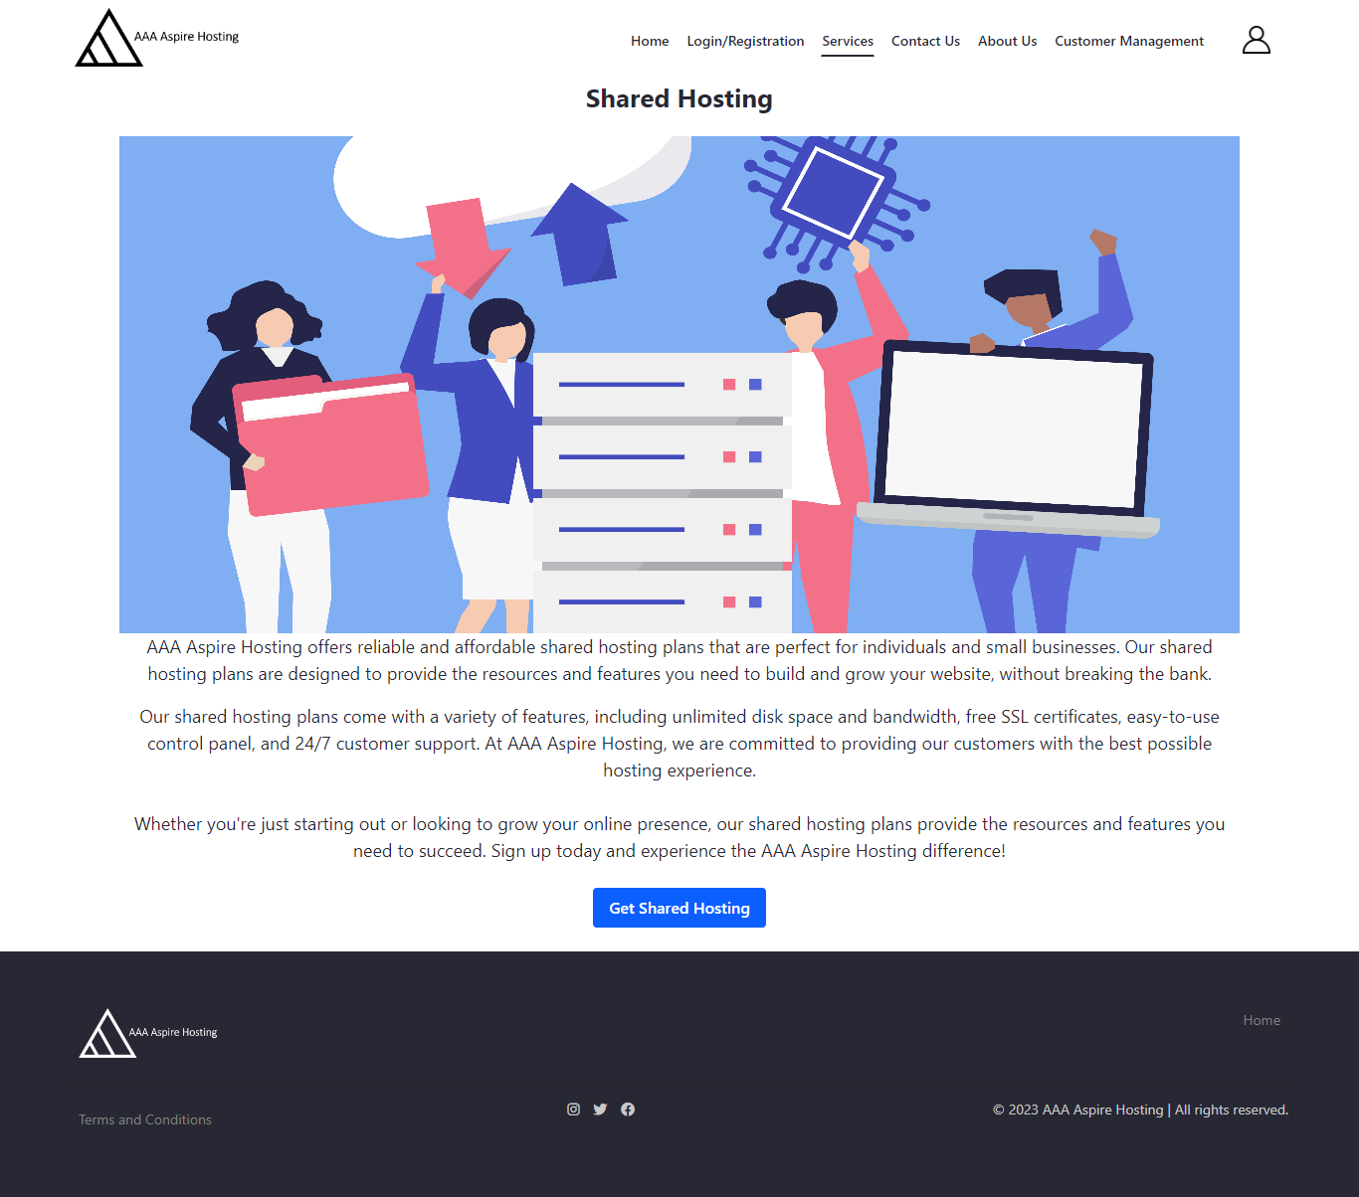

* + - 1. Reseller Hosting service page

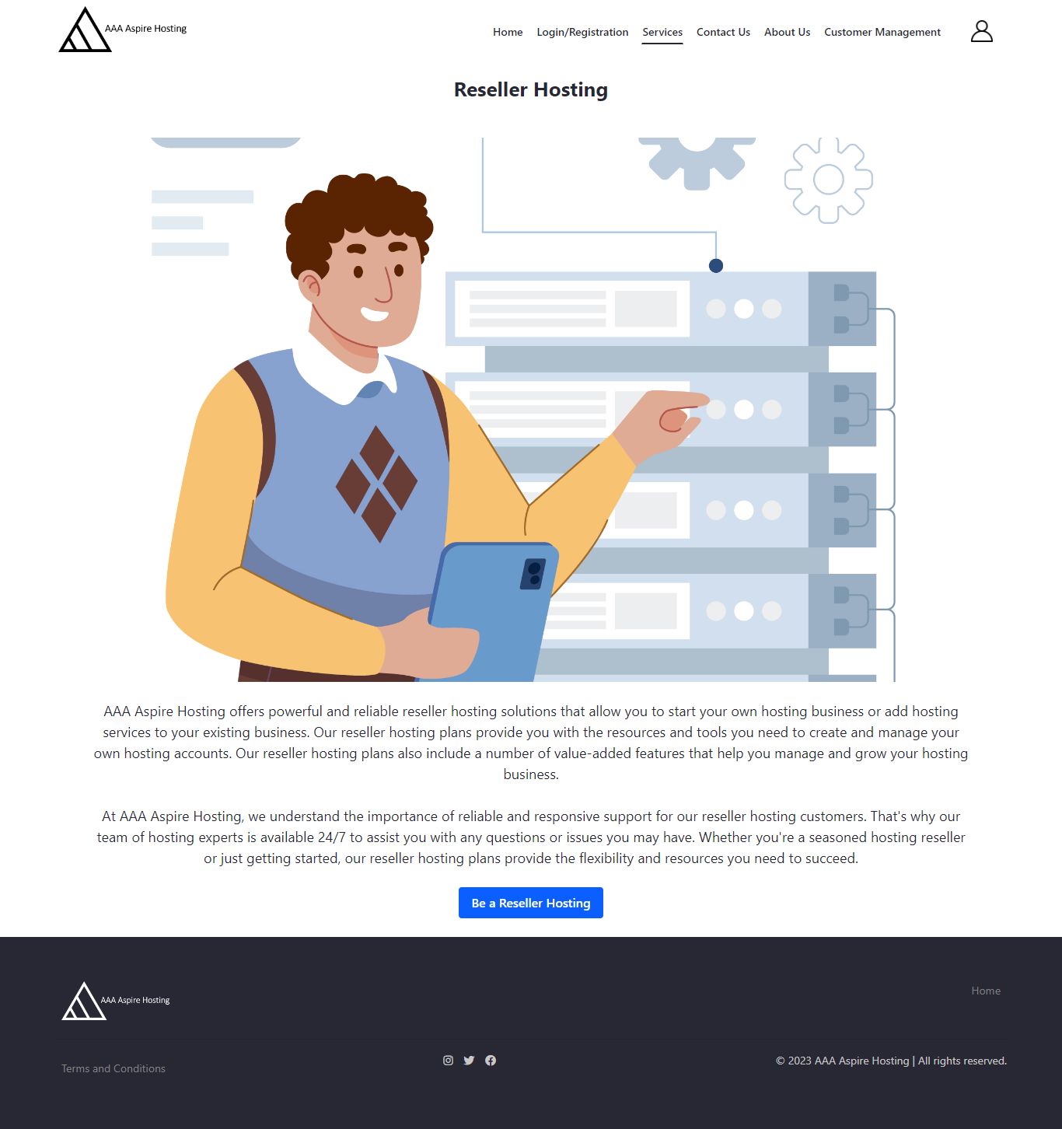

* + - 1. Cloud Hosting service page

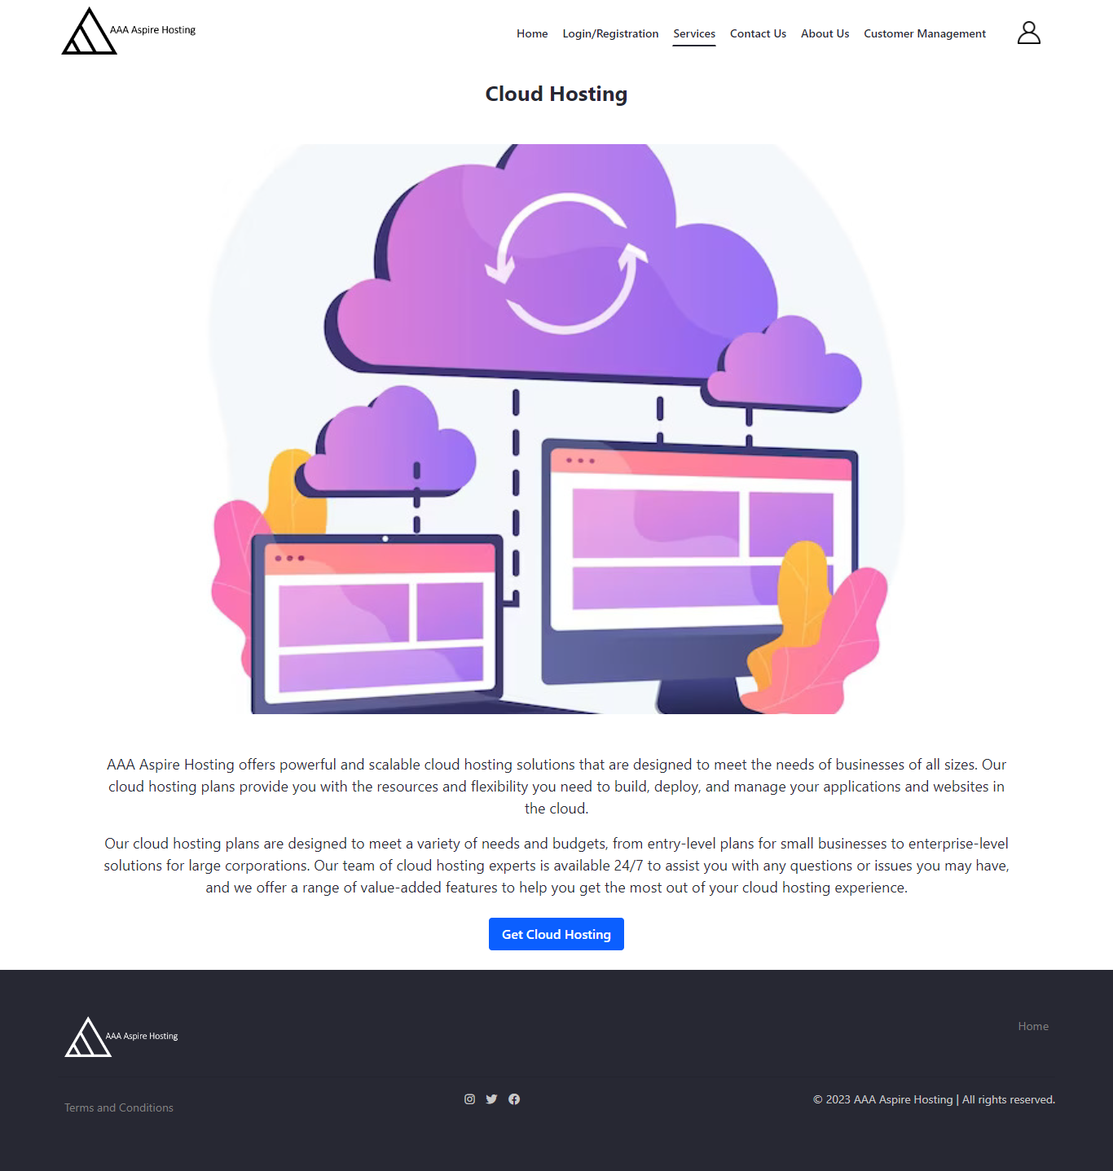

* + - 1. VPS Hosting service page

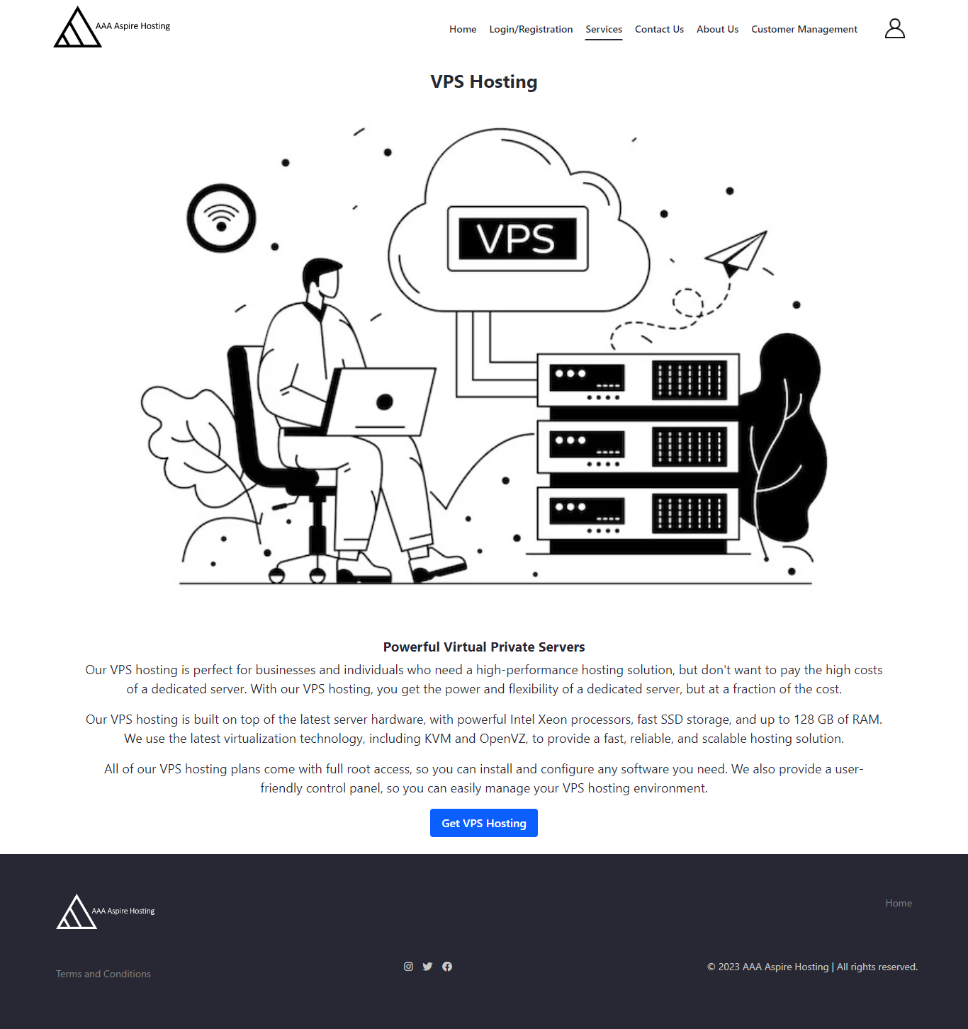

* + - 1. Dedicated Hosting service page

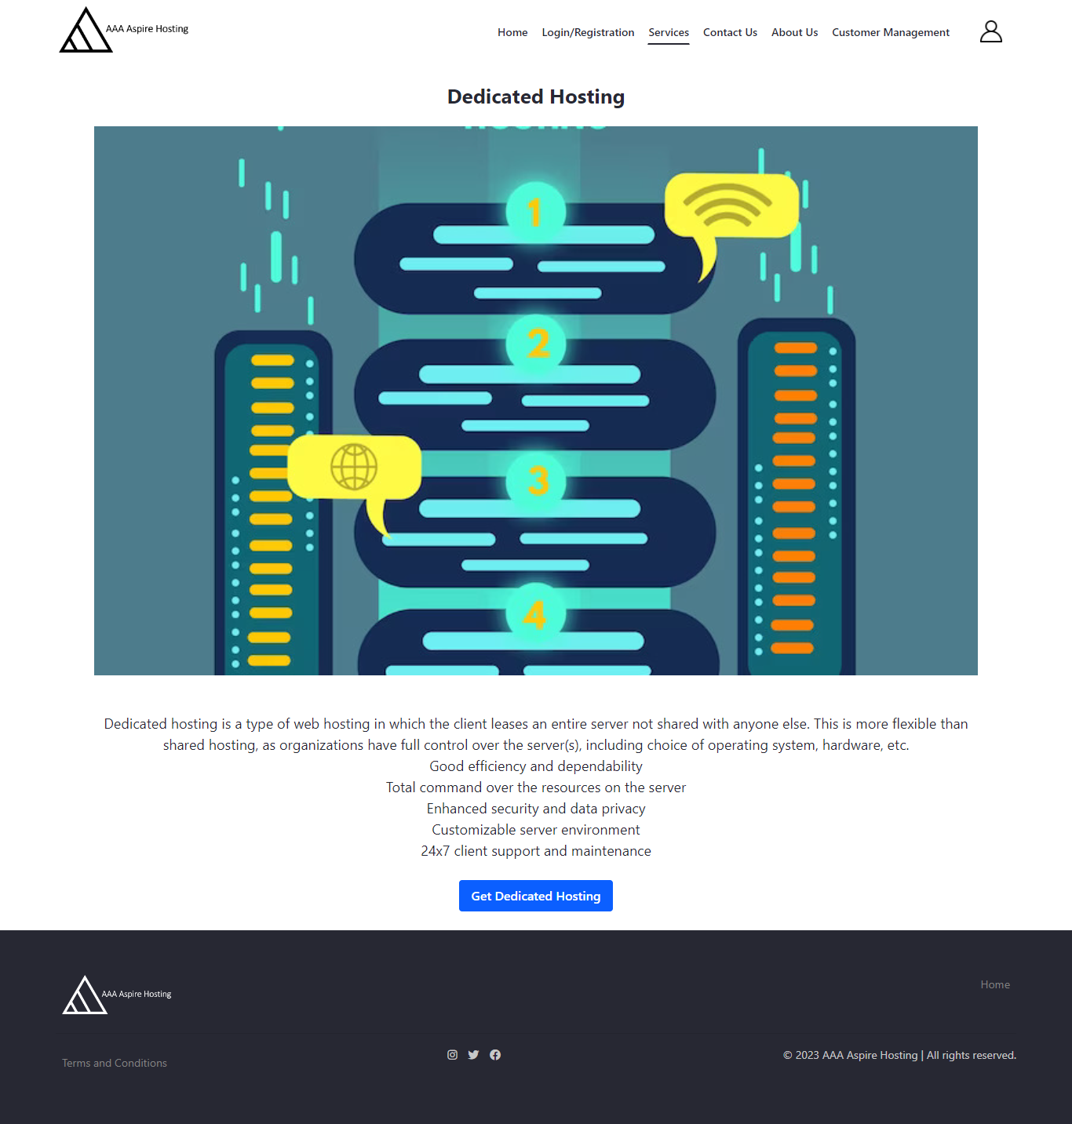

* + - 1. Colocation service page

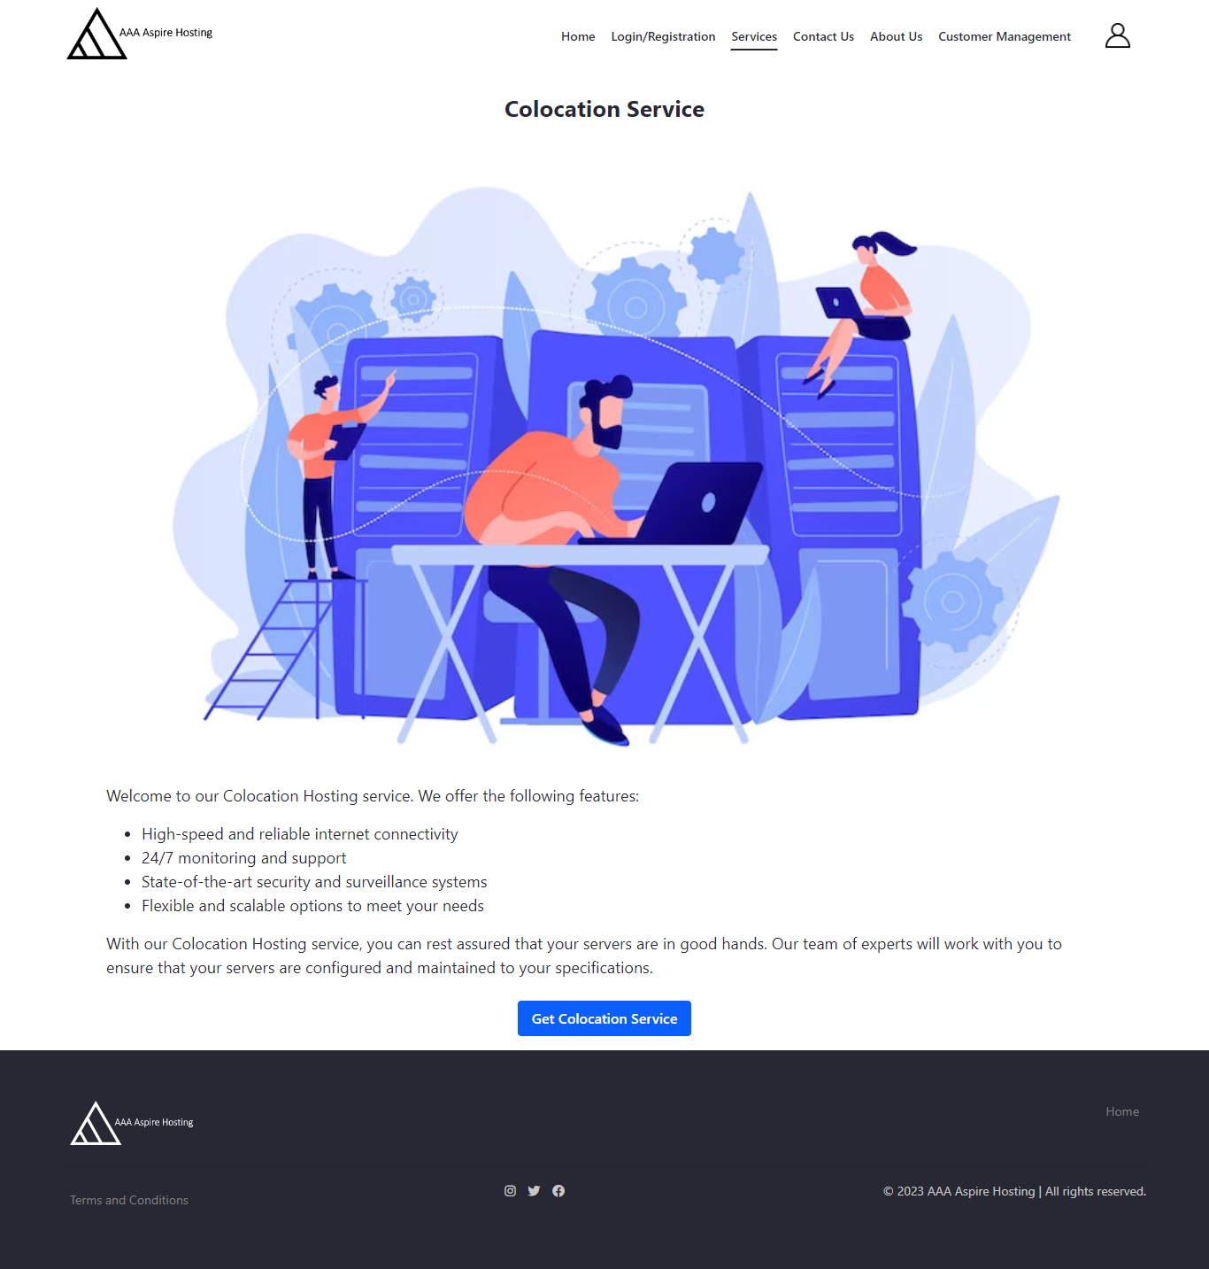

c) Register/Login Page

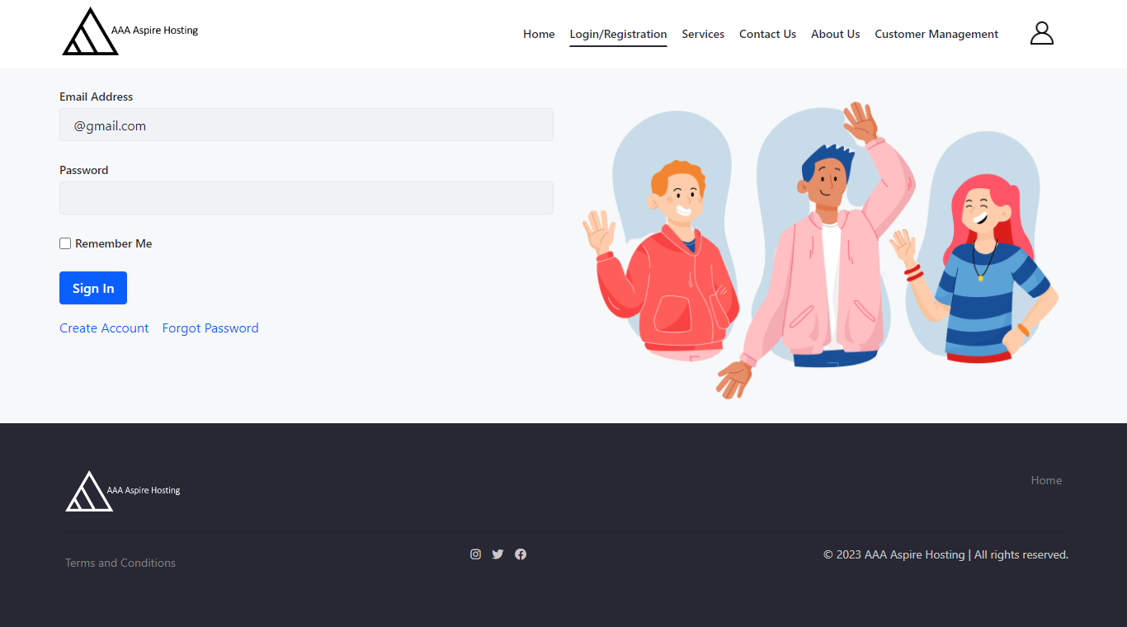

d) Contact Us Page

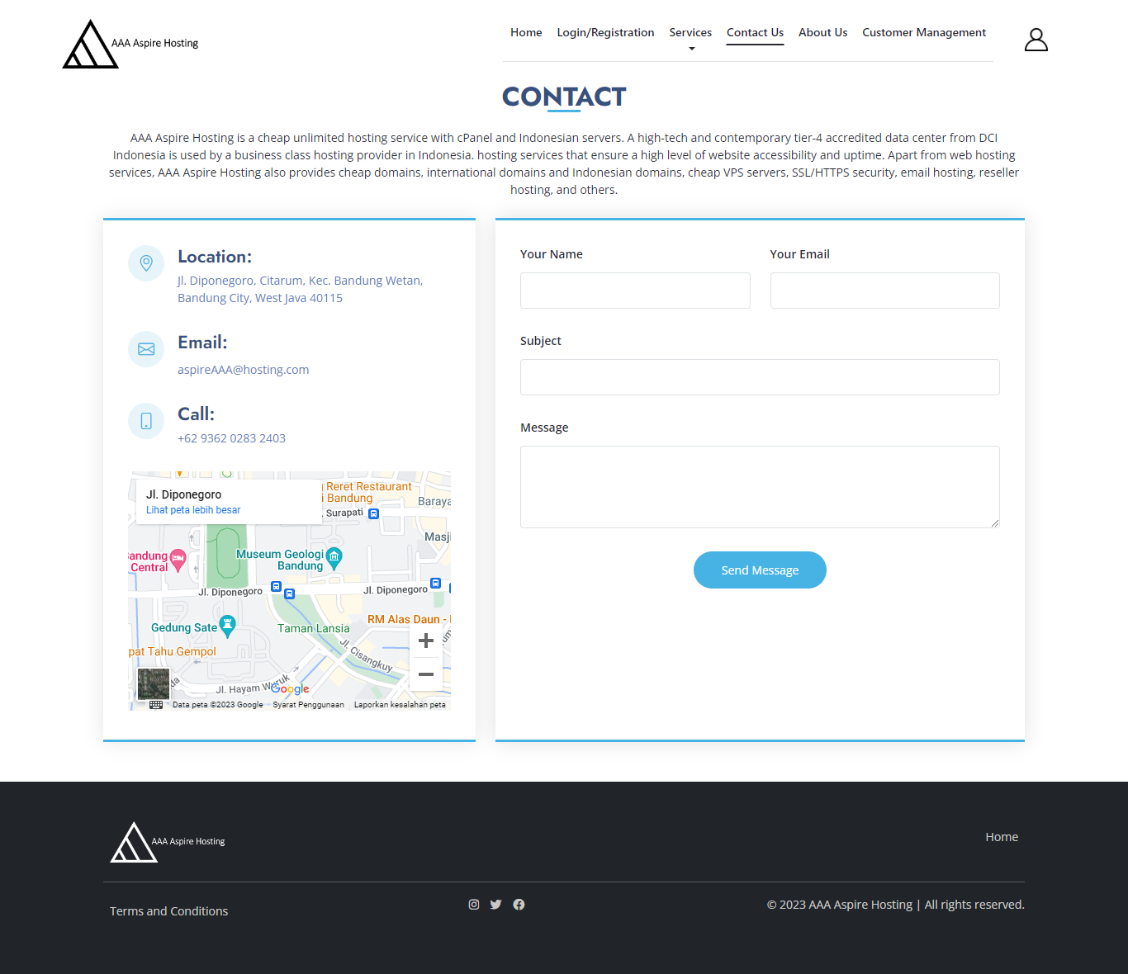

e) About Us Page

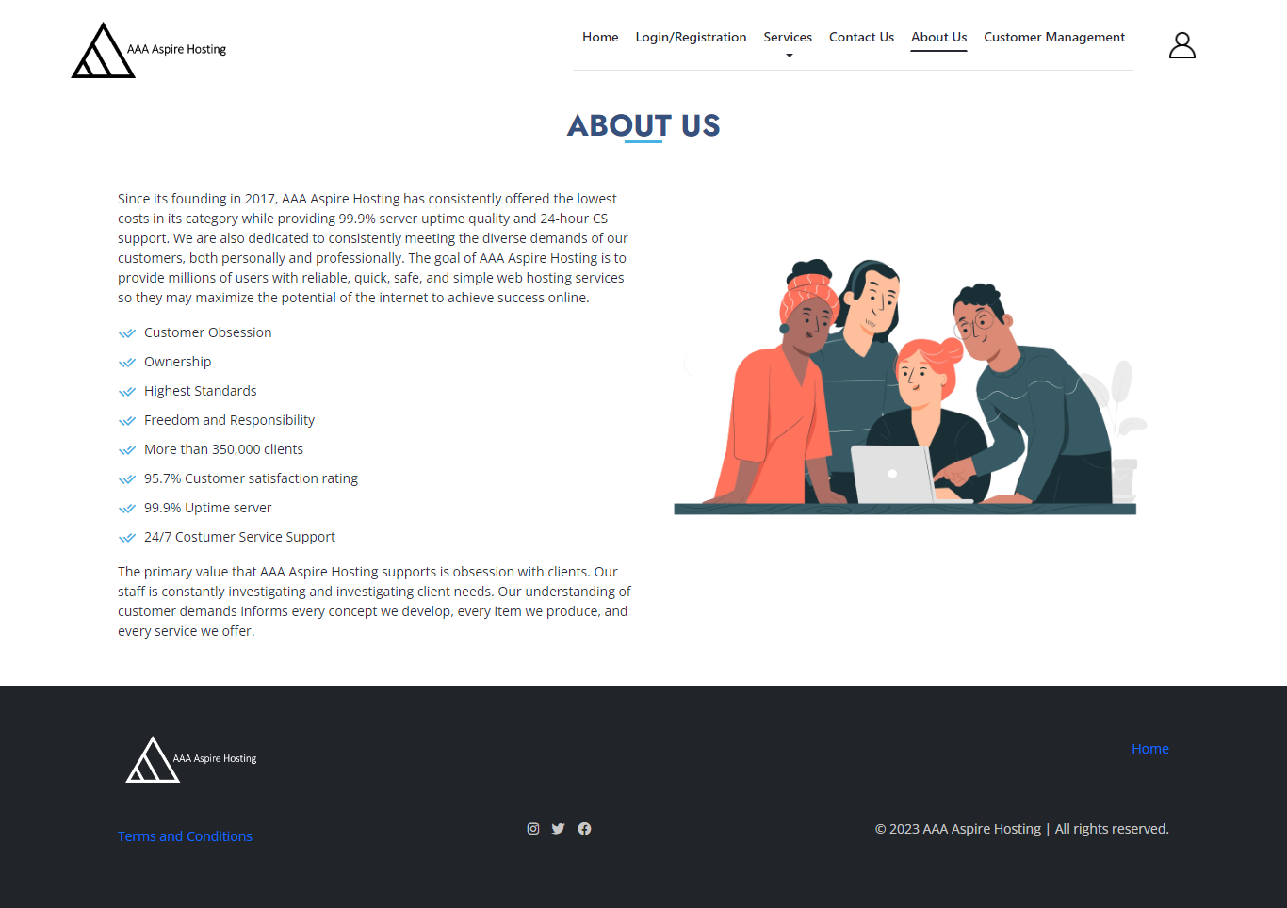

f) Terms and Condition Page

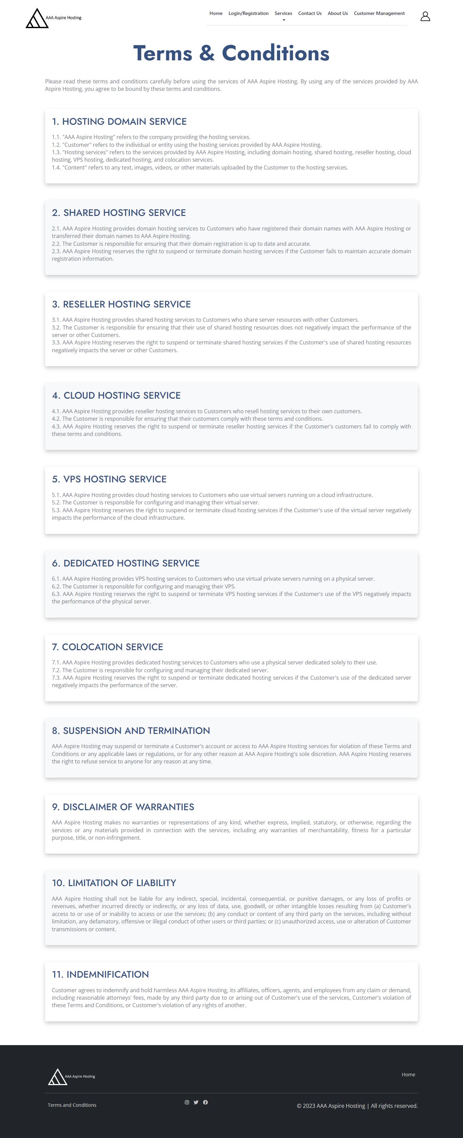

g) Customer Portlet

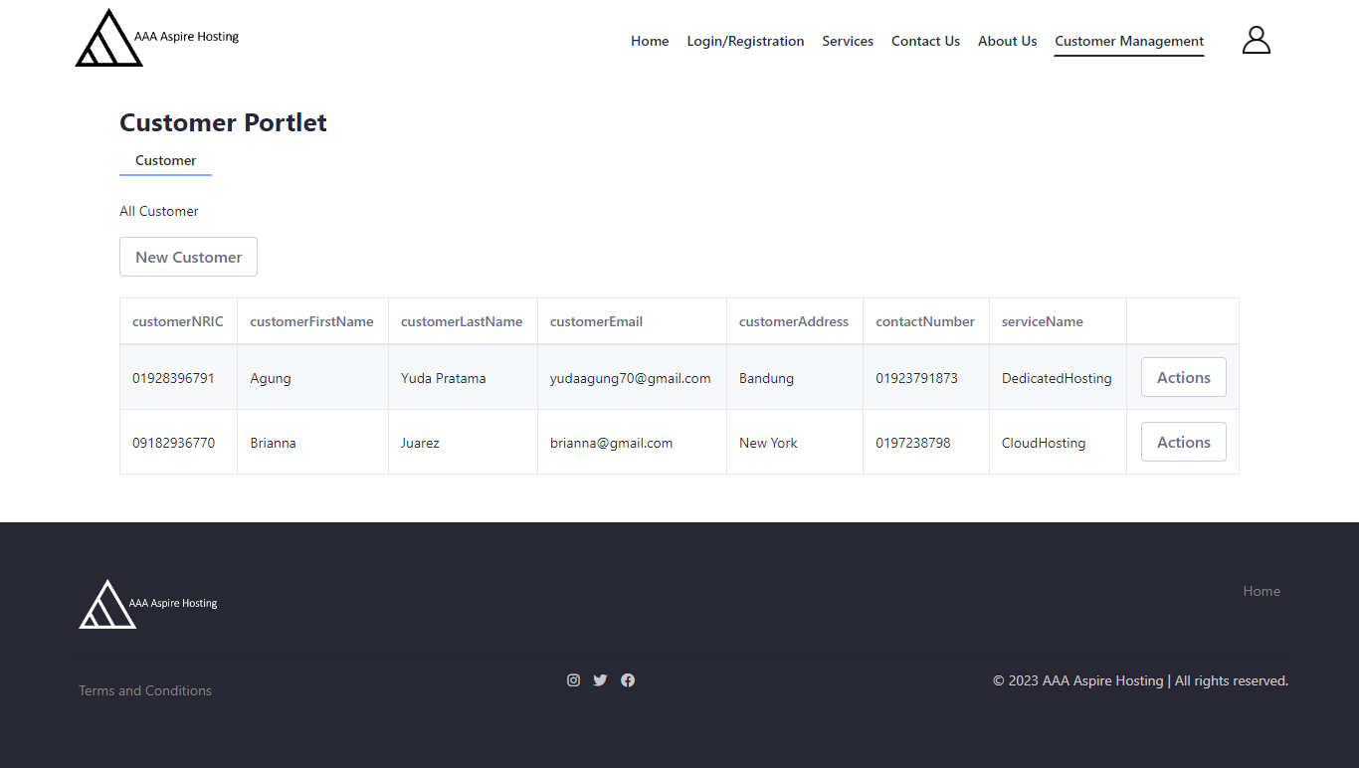

8. Provide screen capture logging in with two different users (Administrator, Site Member) showing Permission for Customer and Service Portlet.

Go to Site builder and click pages, after that click 3 dot and click permission on the page portlet

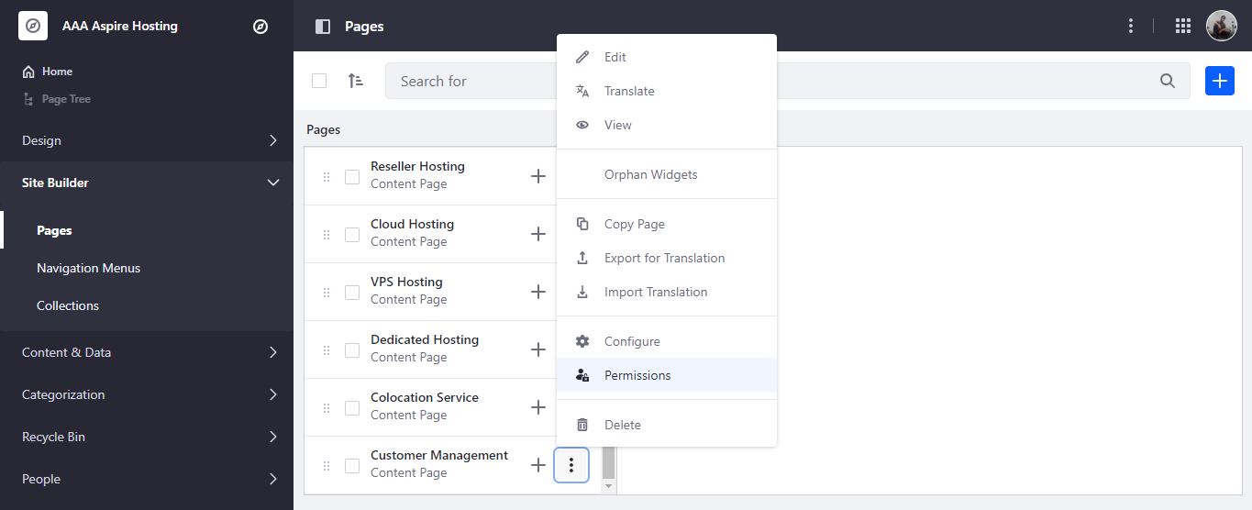

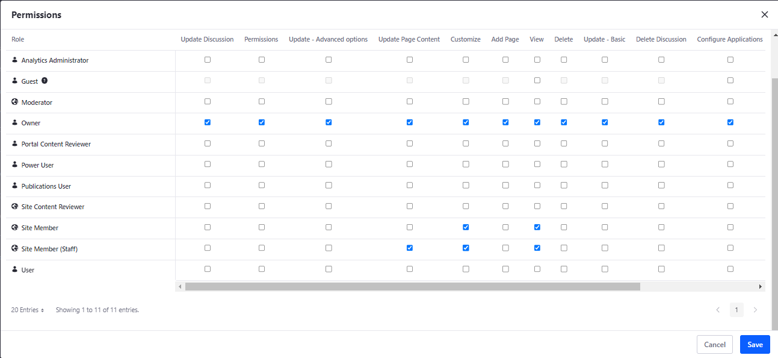

**8. Develop an application that implements design patterns and utilizes techniques to produce secure code. Provide the implemented code as evidence.**

The factory design pattern, facade, and template technique are the three potential design patterns that have been found.

Polymorphism is utilized for the factory design pattern as demonstrated below:

getInstance() method in the ServiceContextFactory class

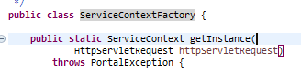

Method invocation statement from CustomerPortlet.java (controller class)



Polymorphism allows the serviceContext object above to be instantiated using the getInstance() method in more than 1 form depending on the request object, Customer. The advantage of polymorphism is that the code can be reused multiple times without affecting the original code.

CustomerLocalServiceUtil is the facade class in the facade design pattern since it conceals complexity beyond it. The section of code below shows that the facade class encapsulates the complex system in a single interface object: the CustomerLocalService. Within the facade class, each method, such as addCustomer(), returns the getService() function, which references the CustomerLocalService object.

Facade Class

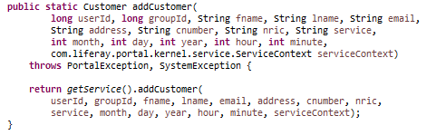

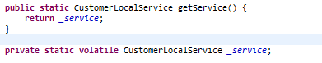

The facade design pattern uses encapsulation through data hiding, keeping all of the CustomerLocalService's data members private so that no other class can access them. Critical data is protected by the restriction to the CustomerLocalService class, enhancing security. An interface for customers called CustomerLocalService contains functions like addCustomer() and deleteCustomer(), and others. As it separates the implementation for the interface, the interface provides all business logic or procedures for the customer, offering complete abstraction.

This is parent class





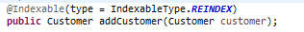

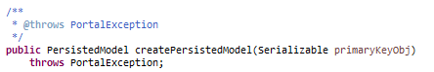

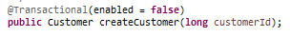

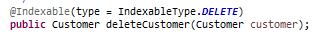

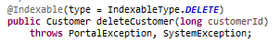

By implementing the interface, the implementing class, such as the CustomerLocalServicelmpl class, which can define the method body, can inherit the parent class's methods and attributes.

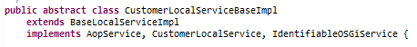

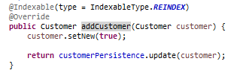

Method overriding is possible because the implementing class has the same method as the parent class, such as the addCustomer() method. Using the interface makes the code more secure since it makes it loosely connected, allowing other parts of the code to be replaced without changing the structure as a whole.

As demonstrated in the template technique mentioned earlier, which uses the Generic Portlet abstract class, abstraction is also accomplished using an abstract class. The class defines the Portlet interface's default implementation and the skeleton for creating portlets (Liferay, Upgrading a GenericPortlet. n.d.).

Subclasses of the abstract class can override the method implementation as needed while preserving the parent class overall structure and algorithm sequence. Also, duplication in the code can be avoided. From the section of code below, subclasses use the extends keyword to inherit the GenericPortlet class methods starting from the controller class, CustomerPortlet which uses the MVCPortlet build template. There is multi-level inheritance as another class has already extended from another class.









**9. Discuss the use of design patterns for the given purpose and consequences by applying design patterns**

The construction of the serviceContext object, which contains context information like the userld for the Customer object, was made more loosely linked by the use of the creational design pattern, especially the factory design. Get methods like getUserId() can be accessed straight from the client code because the serviceContext gathers all information on the requested item. Because the factory function conceals the Customer object's creation logic, there is no need to directly instantiate it each time context information is required. The disadvantage of the factory technique is that it may call for a large number of classes, adding to the complexity of the system. Refactoring will be time-consuming because creation in the subclasses is abstracted and necessitates a full inquiry from the factory class.

When it comes to structural design patterns, the facade pattern allows the CustomerLocalServiceUtil class facade class to hide the complexity of the subsystems that implement the CustomerLocalService class methods and attributes. By reducing the direct reliance on numerous classes and concentrating all access through the facade class, this makes sure that access to the service layer is made simpler. As a result, the pattern enables loose coupling of components, which increases the system's flexibility and ease of expansion. Nevertheless, since a facade must be integrated into the existing code, its implementation will be difficult and time-consuming. Also, high dependency to the facade class will pose a risk which can affect the business logic in creating, deleting or updating the request object, Customer.

The controller class, CustomerPortlet, uses the template build, MVCPortlet, which is a straightforward extension of GenericPortlet, for the behavioral pattern template method. Because the generic portlet defines the ways to build portlets, using this design helps reduce boilerplate code. Due to inheritance, this style also allows for the flexibility of subclasses to implement the GenericPortlet's methods. The drawbacks of this pattern include the possibility that a template may restrict the development of a specific design and the maintenance problems that may arise if there is any disruption in the high- or low-level classes, making it challenging to troubleshoot and fix.

**10. Investigate how different design patterns can work within a range of different scenarios.**

**(Non-BTEC Task 4 - 2)**

**Design Patterns**

**1. Creational Design Pattern**

**Factory Pattern**

Scenario: The FactoryPattern Demo uses the LaptopFactory to create different types of laptop by sending information (ASUS/ ACER/ AXIOO) to the LaptopFactory to get the type of laptop requested. laptop is an interface implemented by the 3 concrete classes (AsusLaptop, AcerLaptop, AxiooLaptop) and by referring to a common interface other kinds of laptop can also be created and the client is not exposed to the creation logic.

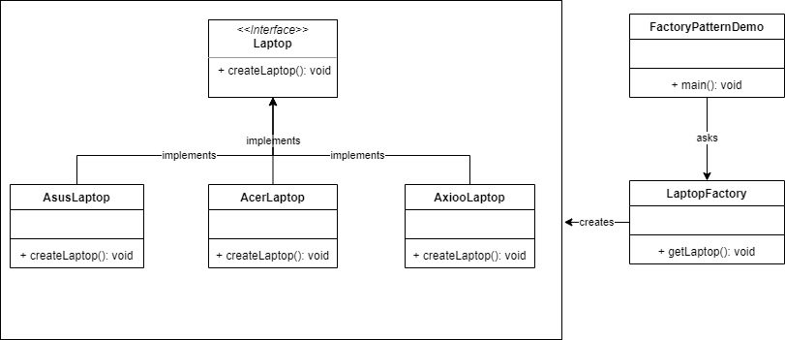

**Builder Pattern**

Scenario: considering a Restaurant where different kinds of menu can be prepared. The builder pattern is able to show the food preparation process step by step. This is achieved from the Item interface representing all food items which implements the Item interface. The food can then be created by adding into an Arraylist and the FoodBuilder will build different combination of Foods based on the Restaurant menu. The builderPattern Demo will ask/use the Food Builder to build a food ready to serve for the customer.

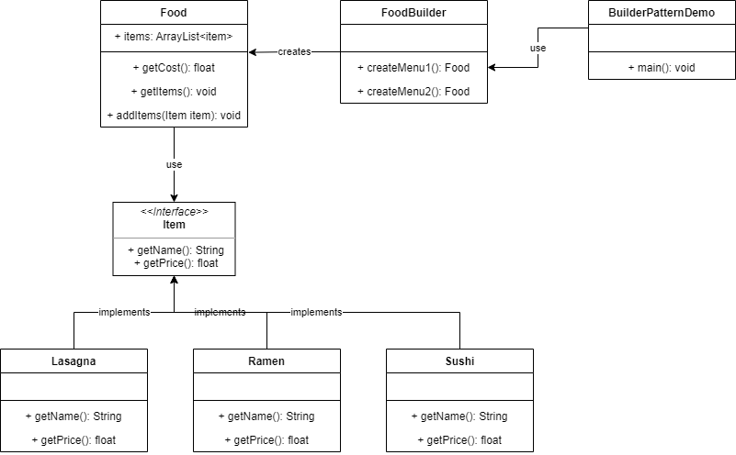

**2. Structural Design Pattern**

**Adapter pattern**

Scenario: The BirdAdapter is depicted in the diagram as serving as a link between ToyDuck and Bird, two incompatible interfaces. The BirdAdapter class is in charge of connecting the interfaces' functionality so that the PlasticToyDuck may create a squeaking noise that is identical to that of a real bird, in this instance the crow sound.

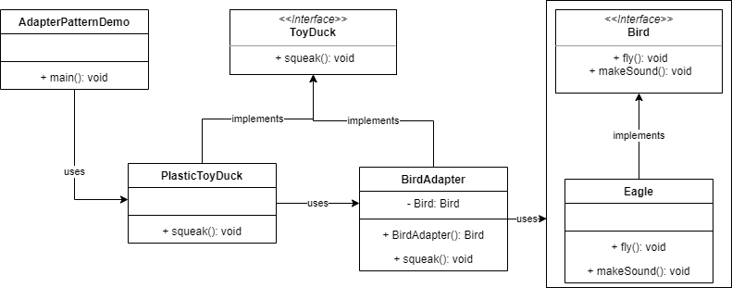

**Facade Pattern**

Scenario: A client or customer is interested in learning about the various menus offered at the hotel's restaurants. Ask the hotel manager, and he will take care of any complicated implementation so that the client gets what they asked for. As a result, the hotel manager is the façade and conceals the complexity of the hotel system. This can be done via the hotel interface, which returns menus, and it can also be done by using the restaurants nearby; for instance, a vegan restaurant will return a vegan menu. The person who gathers and keeps all the menus on hand whenever a customer requests one is the facade class or the hotel keeper.

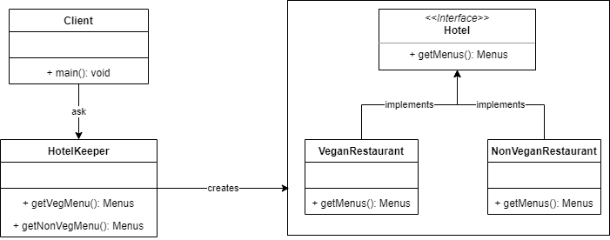

**3. Behavioral Design Pattern**

**Command Pattern**

Scenario: The Order interface serves as the command in the command pattern, and the Stock class serves as the request. The execution of Order Interface classes will handle the command itself. The invoker, or Broker class, can accept and place orders as well as choose which command to run.

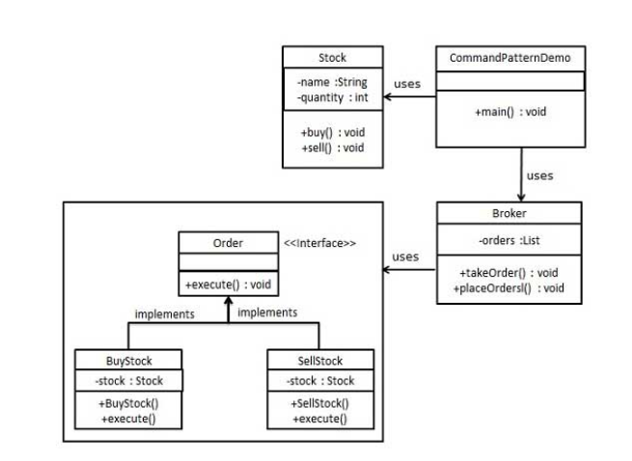

**Mediator pattern**

Scenario: According to the diagram, the chatRoom is in charge of displaying messages to all users. The chatRoom method will be used by the User object to communicate. The User objects in the MediatorPattern Demo will be used to demonstrate communication with any User.

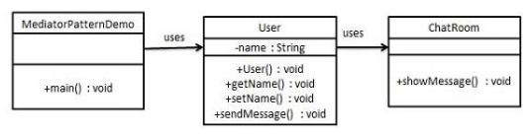

**11. Identify the appropriate design pattern from the investigation.**

**(Non-BTEC Task 4 - 3)**

**Guidance**

From P4’s investigations, reconcile the most appropriate design patterns from

a range with a series of given scenarios (Given Scenarios mention from P4)

1. Among 2 different scenarios in creational design which you have analyzed in P4, reconcile most appropriate design pattern.

The factory design pattern is the most suitable creational design among the factory and builder methods. By encouraging loose coupling, this design pattern eliminates the requirement to link code to particular application classes. Instead, it allows any classes that extend or implement an abstract class or interface to use its factory method. The design pattern is also helpful since the subclass can select the object to build, which is helpful because sometimes it's unclear which object should be created. Polymorphic behavior can be added to the instantiation of an object using the factory method to build an object based on the data from the client or customer.

1. Among 2 different scenarios in structural design which you have analyzed in P4, reconcile most appropriate design pattern

The façade pattern encapsulates system complexity into a single interface object and is the most suitable structural design pattern. Because the façade is the only point of access to the system, the consumer may easily access all of its functionality that is pertinent to their needs without being aware of the complexity. A facade or wrapper class can conceal the complexity of a single straightforward interface.

c. Among 2 different scenarios in behavioral design which you have analyzed in P4, reconcile most appropriate design pattern

The mediator pattern puts a layer between interactions of several objects to decouple or separate them from being tightly coupled, making it the most suitable behavioral design pattern. The layer or mediator acts as a router with its own logic to facilitate communication between objects. This describes how a group of items interact when senders and receivers indirectly reference one another.

**12. Evaluate and justify the design patterns that you had identify in each of the scenarios.**

**(Non-BTEC Task 4 - 4)**

Creational design patterns raise questions about the issue of object generation. A class can assign the task of creating objects to subclasses using the factory function. In this manner, the instantiation might change without affecting the class. New classes can be added to build a new product that shares the interface's commonality by merely extending or implementing the interface or abstract class. This is appropriate when the goods that need to be generated are either unknown or not known in advance and can profit from the subclass management strategy. The authentication system, which has an authentication process that can alter depending on user authorization, is a good example of a system that benefits from the factory technique.

Structural design patterns emphasize how classes and objects can be combined to create larger structures. Particularly the facade pattern offers a means of reducing a complicated structure. The facade class is only serves as an interface and has the ability to delegate various functionalities to make controlling the system's subcomponents as easy as possible. Since the class will be the only instance on which the clients will be solely dependent, the underlying supporting systems are hidden, which lowers the complexity overall. The facade style also encourages loose coupling because it relies on a single class as the main master interface. This strategy is helpful when the system needs to adjust to the possibility of growing and becoming more flexible.

Similar to the mediator, a behavioral pattern that prevents direct communication between objects encourages loose coupling. By routing communication through the mediator, this architecture can manage many objects that refer to one another, such as sending and receiving messages from many users. A communication sent by a user first passes via the mediator before being sent to the recipient. Hence, this approach guarantees readability and maintainability of the code.